Year 5 Homework

Date homework set: 23.11.23
To be returned to school by: 28.11.23

Talking Topic
- To discuss the following topic:
“Why is buying Fairtrade important?

Tick when you have completed this task.
Maths Complete and learn the following;
What fraction of the shapes below is coloured black?

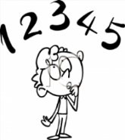
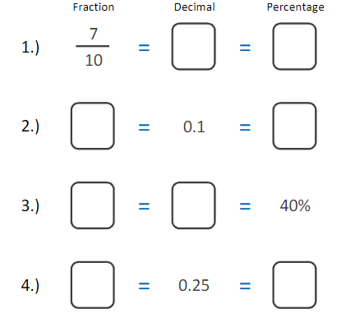
- On Times Table Rock Stars complete the next level. Lets
- see who can win this week’s competition.
Tick when you have completed these tasks.
Reading: Read the next chapter from your new reading for pleasure book.
- Continue with your next book mark.
- Read to an adult and ask them to sign your Reading Diary.
Tick when you have completed this task.

Spelling
Learn this week’s spellings.
community
equip
appreciate
curiosity
desperate

Tick when you have completed this task.

Spag.
Complete the activity below.

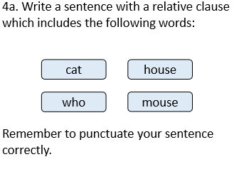

Writing
- Write a description of Mrs Evan’s kitchen.
Key Skill: Metaphors / Similes.
Tick when you have completed this task.

