Friday, 24 November 2023
Dear Parents/Carers,
Punctuality
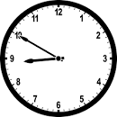
We had 8 hours and 15 minutes of lates this week, meaning vital learning is still being missed by some children.
Please ensure that your child is in school before the gates closes at 8.50am each day.

There are two classes in school where all of the children have been in school on time this week.
-Squirrel Class Y1K
-Kingfisher Y4R

Attendance
Our overall attendance for this week is 95.28%. This is a huge improvement and is very close to our target of 96%. I am absolutely delighted. Please keep this up!
The classes with the best attendance this week are:
- Owl Class Rec 98.29%
- Kingfisher Class Y4R 98.15%
- Hedgehog Class Rec 97.94%
- Felis Silvestris Class Y5B 97.32%
- Martes Martes Y5H 97.22%

WELL DONE!

Events This Week
- Y4 children watched a film at the cinema yesterday.

Upcoming Events

- On Friday 1st December, we are inviting children to bring a chocolate/sweet donation for the Christmas Fair and in return, they can wear non-uniform for the day.
This can be a bar, packet or tub of sweets or chocolate. All donations must be suitable for vegetarians or be halal.

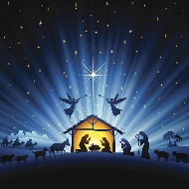
Nativity
Our nativity shows for Reception and Year 1 will take place on Monday 11th December at 2pm
Tuesday 12th December at 9.30am.
The Year 1 children will be performing the nativity and the Reception children will be singing festive songs.

We need to issue tickets for these shows, to ensure that our numbers are within the safe limits for our fire regulations.
Parents/carers will be able to approach staff from their child’s class before and after the school day, starting from Monday.
Each child’s family will be able to have two tickets initially, but can request a further ticket, and these will be issued if there are additional spaces.

Online Safety
We have developed a new online safety hub, along with a company called Smoothwall who are working with our school. They have provided us with a wide range of helpful guides.
https://reedley-lancs.onlinesafetyhub.uk/
There are lots of tips and information under Parental Advice.

Here is one example, which is all about YouTube.
I have copied some of the key tips for you. the advice is geared towards teenagers as there is an age restricted of 13 for children to access the content, but some of the advice is relevant to children of all ages.

How can I make YouTube safer for my teenager?
Here are our top tips for helping to make YouTube safer for your teen:
- Install parental controls to help monitor online activity and screen time. Ensure screen time restrictions are included in your family tech agreement and ask your children to set a timer when using the platform.
- Consider setting up a Parent Supervised user account, or set up a family account and watch YouTube together to find and subscribe to channels with great content.
- Turn on YouTube restricted mode and disable the messaging and chat function.
- Disable in-app purchases on your child's device.
- Turn off auto-play, which is set to 'on' as a default.
- Install YouTube Kids as a safer choice for younger children or select the ‘Explore’, ‘Explore More’ or ‘Most of YouTube’ options in the platform’s settings.
- Encourage quality over quantity and ask your children to use YouTube to learn new skills or for educational purposes.
- If there is a particular channel you don’t want your child to watch, select the ‘Don’t recommend channel’ option within the channel’s settings so it won’t display on your child’s recommended list.
- Don't rely on parental controls and filters. Ensure you continue to monitor your child's YouTube use and report any inappropriate content.
Key Dates
Upcoming Events later in the term
These are a few weeks away, but I know people like to make arrangements for some school events.

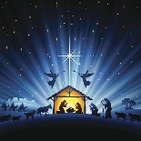
- Reception/Year 1 Nativity
Monday 11th December at 2pm
Tuesday 12th December at 9.30am
Tickets will be available nearer the time
- Online Safety Session for parents/carers
Wednesday 13th December 9am – 10am
Your children can also join for part of the session if parents/carers are present
This will be a very useful session where you will learn how to put parental controls on any devices at home.
- Christmas Fair
Thursday 14th December from 3.40 – 4.40pm Christmas Fair
Friday 1st December Non-uniform day in return for chocolate/sweet donation for the fair.
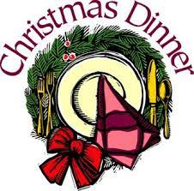
- Christmas Dinner and non-uniform day
Friday 22nd December

- School closes for Christmas break
School closes after school on Friday 22nd December and reopens on Monday 8th January.

Thank you for your support,

Mrs Sarah Bell
Headteacher

