Year 5 Homework

Date homework set: 21.12.23
To be returned to school by: 9.1.23
Merry Christmas and well done to you all. You have been amazing!
When completing your homework try and do a little every day and not all at once.
Talking Topic- To discuss the following topic:
- “What I have enjoyed this term?”
Tick when you have completed this task.
Maths Complete and learn the following;
9.2 x 10 = 100 x 0.3= 24 x 1000 = 1.2 ÷100 =
Complete the calculations below. Remember to use the ‘chunking method’.
- Complete the task below.
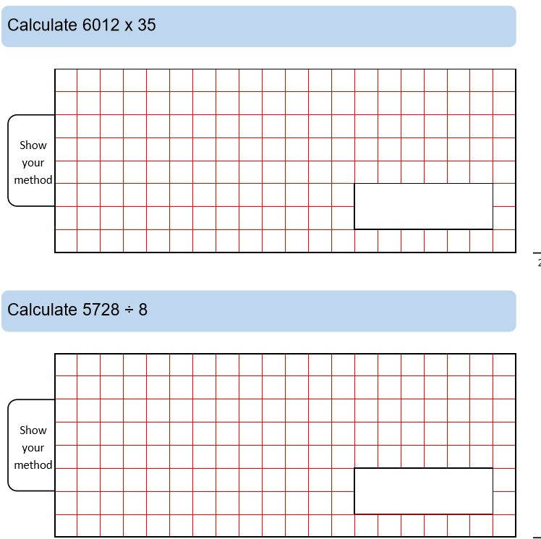

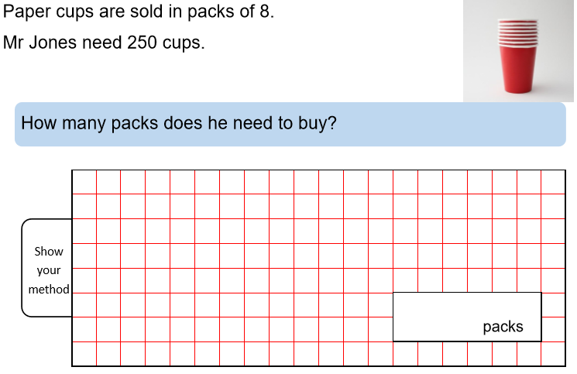
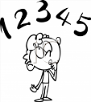
- Times tables Rock Stars.
Tick when you have completed these tasks.

Reading
- Read the next chapter from your new reading for pleasure book.
- Read a book on Bug Club
- Continue with your next book mark.
- Read to an adult and ask them to sign your Reading Diary. Your reading diary will be checked.
Tick when you have completed this task.

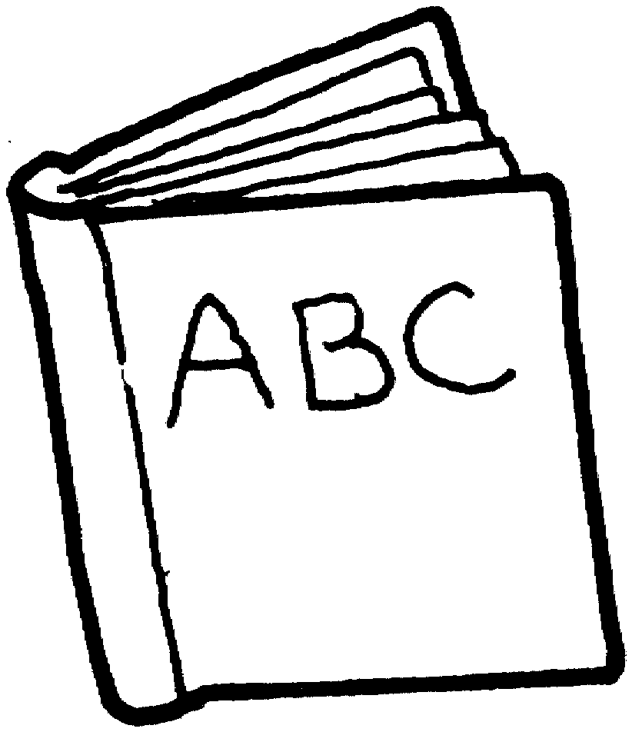
Spelling
Practice this week’s spellings and include each one in a sentence.
Calendar
Caught
Circle
Complete
Consider
Tick when you have completed this task.
Writing
Key Skill: Sentence must make sense and relative clauses.
I want you to write the story of the nativity play. Think about the story Year One and Reception class told.

