Year 5 Homework

Date homework set: 11.1.24
To be returned to school by: 16.1.24
When completing your homework try and do a little every day and not all at once.
Talking Topic
- To discuss the following topic:
- “How do the Earth, sun and Moon fit within our solar system?”
Tick when you have completed this task.
Maths Complete and learn the following;
There are _____ days in a year.
There are _____ days in a leap year.
There are _____ weeks in a year.
There are _____ months in a year.
There are _____ years in a decade.
There are _____ years in a century.
There are _____ years in a millennium.

Time facts
There are _____ seconds in a minute.
There are _____ minutes in an hour.
There are _____ hours in a day.
There are _____ days in a week.
There are _____ days in a fortnight.
There are ___, ___, ___ or ___ days in a month.

- Times tables Rock Stars.
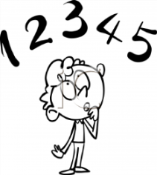
Tick when you have completed these tasks.
Reading
- Read the next chapter from your new reading for pleasure book.
- Read a book on Bug Club
- Continue with your next book mark.
- Read to an adult and ask them to sign your Reading Diary. Your reading diary will be checked.
Tick when you have completed this task.
Spelling: Learn this week’s spellings and include each one in a sentence.
Achieve
Category
Develop
especially

Tick when you have completed this task.
Research: Choose one of the planets from our solar system. Research it and write down at least 5 facts in your book.
Tick when you have completed this task.

