Year 5 Homework

Date homework set: 25.1.24
To be returned to school by: 30.1.24
When completing your homework try and do a little every day and not all at once.
Talking Topic
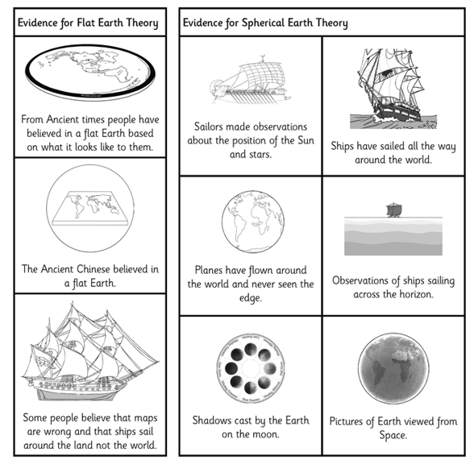
- Talk to an adult about what people though about the shape of the earth.
Tick when you have completed this task.
Maths Complete and learn the following;

Choose an appropriate strategy to solve these calculations

- Times tables Rock Stars.
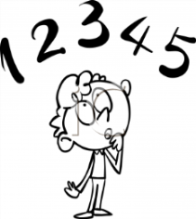
Tick when you have completed these tasks.
Reading
- Read the next chapter from your new reading for pleasure book.
- Read a book on Bug Club
- Continue with your next book mark.
- Read to an adult and ask them to sign your Reading Diary. Your reading diary will be checked.
Tick when you have completed this task.
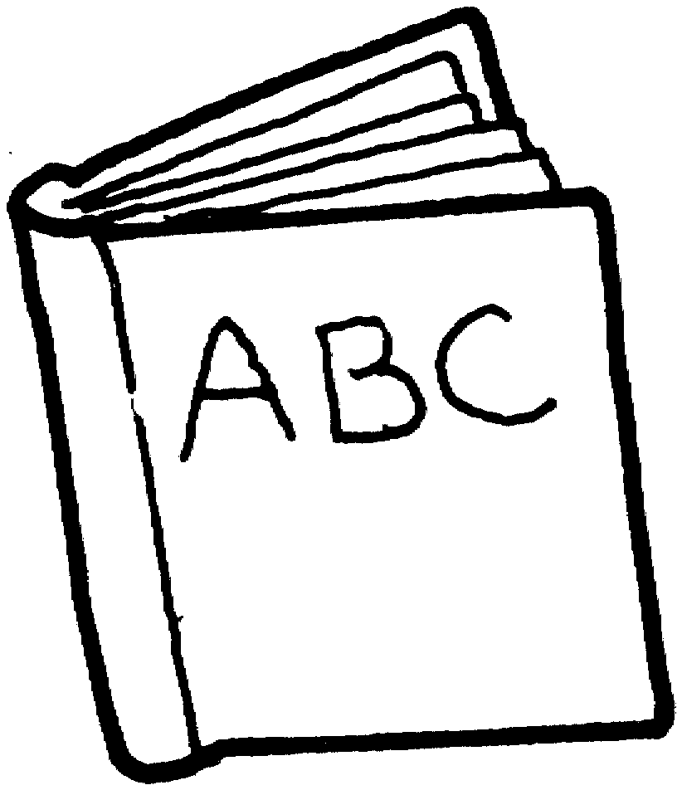
Spelling: Learn this week’s spellings and include each one in a sentence.
excusable
sensible
noticeable
changeable

Tick when you have completed this task.
Research: Using the evidence cards from the talk box above write a short paragraph explaining what the flat and spherical theories are.
Tick when you have completed this task.

