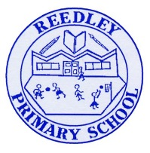
Year 5 Homework

Date homework set: 7.05.24
To be returned to school by: 14.05.24
When completing your homework try and do a little every day and not all at once.
Talking Topic :To discuss the following topic: What does resolution mean?
Tick when you have completed this task.
Maths :
Complete the questions below and Maths Whizz.
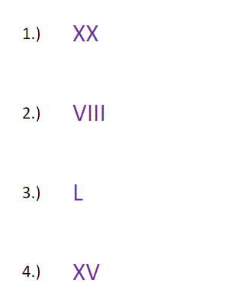
- Times tables Rock Stars.

Tick when you have completed these tasks.
Reading
- Read the next chapter from your new reading for pleasure book.
- Read a book on Bug Club
- Continue with your next book mark.
- Read to an adult and ask them to sign your Reading Diary. Your reading diary will be checked.
Tick when you have completed this task.

Spelling
Learn this week’s spellings
- Necessary
- Neighbour
- Nuisance
- Occupy
- Occur

Tick when you have completed this task.
Spag – Standard English.
This week’s activity is to complete the Spag activity- Parenthesis and commas.Read each activity carefully and complete each question.
Writing.

