Friday, 10 May 2024
Dear Parents/Carers,

Warm Weather
Now we have started to get some warmer weather, it is a good idea to put sun-cream on your child before they come to school and to send them with a hat to wear for playtimes.

Children should also bring a drink bottle with water. This should be clear and should not have flavoured juices.
CHILDREN MUST NOT BRING GLASS BOTTLES as this could be very dangerous.

Lateness
Most of our Y6 children will be sitting their SATs tests next week.
Tests start at 9am. Please ensure that all children are in school on time. If children in the other year groups are late to school, they will not be able to go through the hall and may have to wait for a while until they can be escorted around the outside of the school building to get to their class.

Attendance
Our overall attendance for this week is 92.47%.
This is a slight improvement on previous weeks.

These two classes achieved the 96%+ target this week:
Reception Hedgehogs Class (96.67%) and Y4R Kingfisher (96.59%)

Punctuality
We had 6 hours and 30 minutes of lates this week, meaning vital learning is still being missed by some children. All children need to be in school by 8.50am each day.
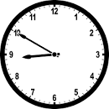
Two classes had all children in school on time this week:
Y4 Starlings, Y5 Felis Silvestris

Upcoming Events
- Y1 are making pizza next week as part of their DT topic.
- 21st May – Y4 will be having an Egyptian day as part of their topic
- 22nd May – Ten children from Y5/6 who have been attending a FBA club (Fantastic Book Awards) all year, will be going on a trip to Preston UCLAN to meet all of the authors of the books they have been reading.
- 23rd May – Y2 will have their trip to Lytham

Online Safety Hub
All Reedley parents can access the Online Safety Hub FOR FREE. Click on the link below to access the Online Safety Hub for lots of expert advice and guidance to help you manage your child's safety online.
https://reedley-lancs.onlinesafetyhub.uk/

Online Safety Pledge
See the link below for an online safety pledge that you can agree to as a family.

Digital Family Pledge - Vodafone UK News Centre

Girls’ Football
Our girls’ football team completed their games for the league yesterday. They won 1-0 yesterday and finished in the mid table overall. Well done girls!
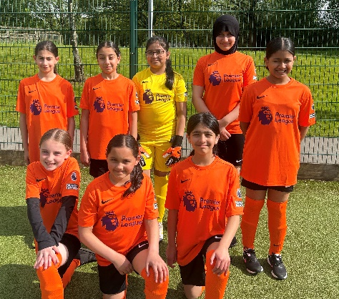

Key Dates
- Y6 SATS tests take place next week. Please ensure that Y6 children are in school on time. Tests start at 9am.
- School closes for half term after school on Friday 24th May and reopens on Monday 3rd June.
- School will be closed for two days for Eid in June on Monday 17th and 18th June.
Sports Days
Monday 10th June | 9.30 | Reception
Monday 10th June | 13.30 | Year 1 and Year 2
Friday 14th June | 9.30 | Year 5 and Year 6
Friday 14th June | 13.30 | Year 3 and Year 4
Sports days will be dependent on fine weather.
Thank you for your support,
Mrs Bell, Headteacher

