Year 5 Homework

Date homework set: 06.06.24
To be returned to school by: 11.06.24
Talking Topic: To discuss the following topic:
“Who was the Highwaymen? ”

Tick when you have completed this task.
Maths Complete the following
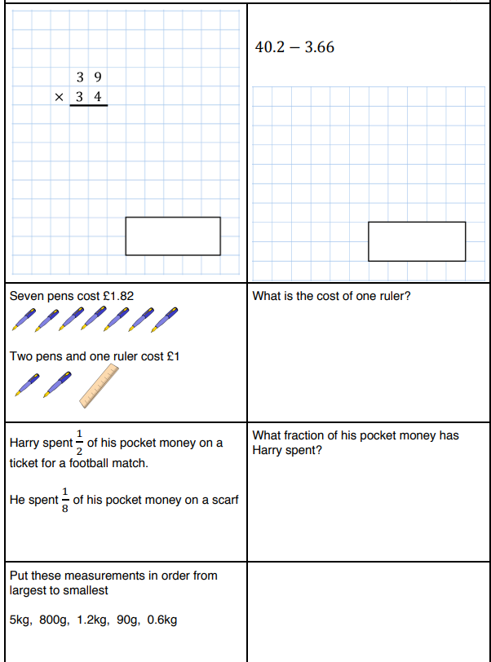

- Complete TTRockstars.
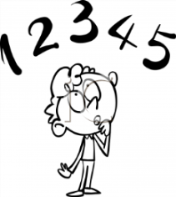
Tick when you have completed these tasks.
Reading Read the next chapter from your new reading book and you must complete the next book mark.
- Continue reading your book on bug club. This activity is part of your homework.
- Read to an adult and ask them to sign your Reading Diary.
Tick when you have completed this task.
Spelling: Learn this week’s spellings.
different, which, ceiling, receive, receipt, deceive

Tick when you have completed this task.
Writing: Write a description about this character.
Key Skill : verb starters (ing words)
Tick when you have completed this task.
