Friday, 14 June 2024

Dear Parents/Carers,

**Attendance**

Our overall attendance for this week is **90.85%.**

The best attendance this week was from Y3V Golden Eagle Class with 97.07% attendance.

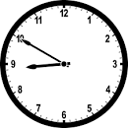

**Punctuality**

We had **5 hours and 20 minutes of lates** this week.

Y5M Felis Silvestris Class and Y1K Squirrel Class had no lates this week.

**Pupil Support Manager**

We welcomed a new staff member this week, Mrs Simmonds. She will be overseeing attendance, punctuality and safeguarding in school.

She will be working with children in school and also with parents/carers.

If anyone feels they need some support from Mrs Simmonds, please contact the school office to make an appointment.

**Donations**

If anyone has any items of school uniform that they have finished with, we would be grateful if you could donate them to school, so we can offer them to families in need. They need to be in good condition and can be left with Mrs Iqbal at the school office. Once we have collected some items we will let you know how you can receive any items for your children.

**Online Safety**

I have attached a poster about YouTube. It is important that parents/carers monitor children’s use on the computer as sites such as YouTube has a wide range of inappropriate content.

I would advise that primary children only access YouTube Kids.

The post also suggests that you set up Google Family



**Events this week**

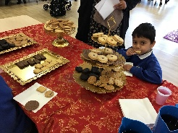 Thank you to all the Reception parents/carers who were able to attend the Eid craft session on Thursday. Well done to Mrs Mahmood and the Reception staff for all their efforts in organising this event.

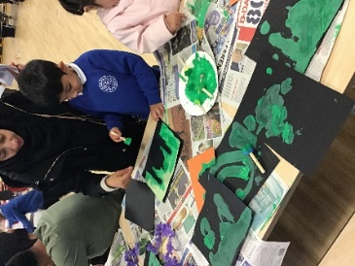

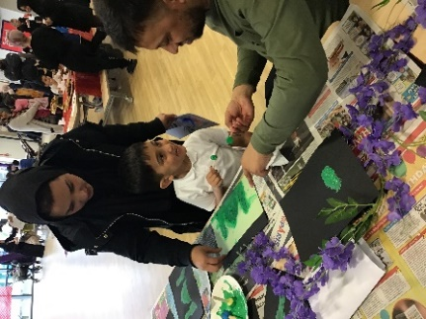

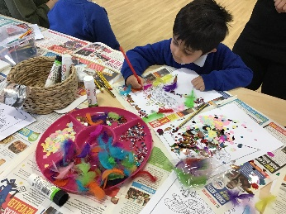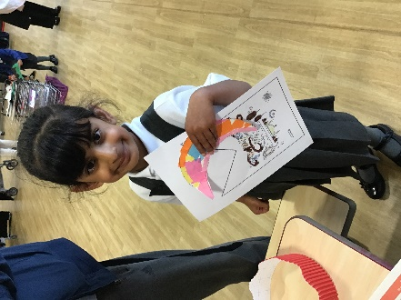

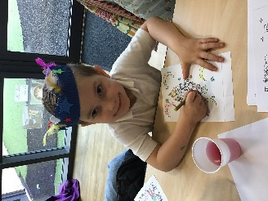

* Three children attended the final of the Spelling Bee. Izaan Imran (Y6), Muhammad Ali Ahmed (Y2) and Maham Shakeel (Y3).We were so proud of them all for their efforts. Izaan Imran won the Y6 trophy from all the schools who took part. We are very proud!

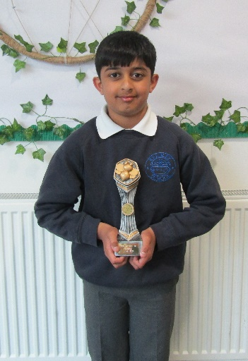

**Upcoming Events**

SCHOOL IS CLOSED ON MONDAY 17TH AND TUESDAY 18TH JUNE

Remember that we are not doing fewer days in school than other schools, we have just planned these days in advance to allow families to celebrate Eid.

* 19th June – all children can wear **non-uniform** following Eid. You don’t need to send any money for this.
* 20th June – Eid Fair 3.45pm to 4.45pm – everyone is welcome to attend. There will be a chocolate tombola, food and drink to buy, balloons, toys and lots of games to play and prizes to be won.

|  |  |  |
| --- | --- | --- |
| **Sports Days** |  |  |
| Tuesday 25th June | 9.15am | Year 5 and Year 6 |
| Tuesday 25th June | 10.30am | Year 3 and Year 4 |

* Monday 1st July at 2.45pm Y4 children will be doing an assembly for their parents/carers, based around Eid. A letter will be coming home asking families to send in a picture of how you have been celebrating Eid.

**Key Dates**

* School will be closed for two days for Eid on Monday 17th and 18th June
* School will be closed all day on Thursday 4th July
* School closes for the summer holiday at 1:30pm on Friday 19th July.
* School reopens to pupils after the summer holiday on Tuesday 3rd September.

I would like to wish all of our Muslim families Eid Mubarak for when you celebrate Eid over the coming days.

I hope you all have a lovely time celebrating.



Mrs Sarah Bell

Headteacher

