Literacy

In literacy we have been learning about the story Whatever Next. Watch the story using this link.

<https://youtu.be/Za-g9y0_Y1s>

What happens at the beginning, middle and end of the story?

What is your favourite part of the story?

What do you like about it?

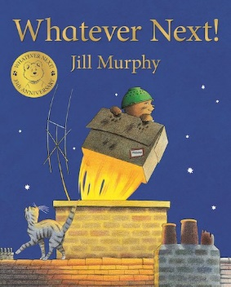Draw a picture of your favourite part and write a sentence about it. You could write ‘The bear goes to the moon’ or ‘He made a rocket’.

Maths In maths we have been investigating subtraction. Practise your subtraction skills with these questions. You could use objects to help you find the answer.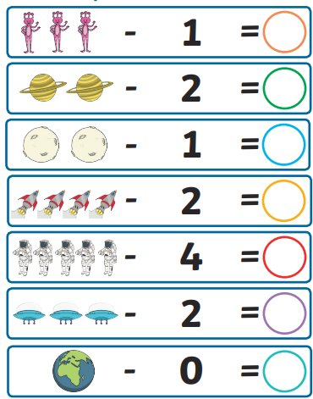

Phonics

[**Lesson 17 - Review oa, oo, ar**](https://www.youtube.com/watch?v=af5mCjvLoSc&list=PLuGr6z2H2KNHBEmnfCUosDI_VQdDuYNG_&index=44)

<https://youtu.be/af5mCjvLoSc>

Topic

Little bear builds a rocket using a box. Can you find anything in your house that you can make a rocket with? You will need windows, a door and fire to make it go. What other parts can you add to your rocket?