Wednesday, 10 July 2024
Dear Parents/Carers,

Reports
You should have received your child’s report today via email. If you haven’t, please contact the school office. If you wish to talk about anything on the report, you can make an appointment to speak to your child’s teacher, again by calling the school office.

Summer Homework
Over the summer break, we want children to have some fun and spend time with family and friends. However, it is a long time to be away from school. We find that the children who do a little bit of learning during holidays, come back to school ready to pick up where they left off.

With that in mind I would urge you to support your child in doing a little bit of work often.
It is a good idea to build some routines.

Maths Whizz
Children from Y2 to Y5 all have passwords for Maths Whizz. The school pays £25 a year per child for these passwords, as we believe that it really makes a difference if they go on it regularly.

There will be some awards presented in September for children who have used this regularly throughout the summer. 10 minutes a day would make such as difference.

Fun Ideas
Please see below for suggestions of activities that your child can do over the summer break.
Other family members can join in too! Look further down the page for the ideas.

If you child takes part in these challenges, they can show their teacher in September.

There are some special certificates that they can achieve for joining in with these activities.
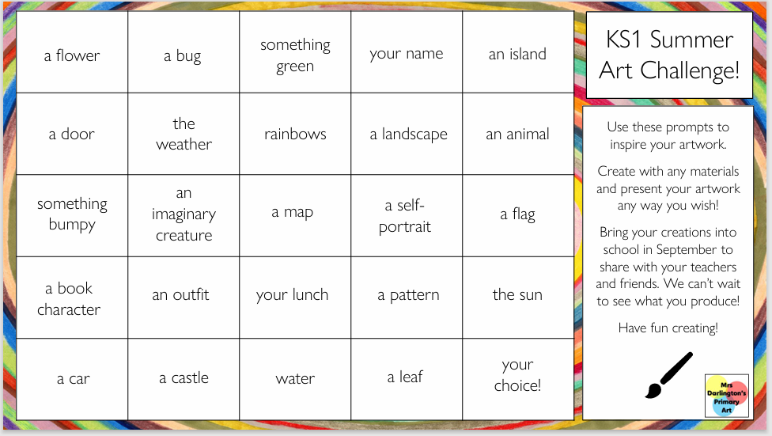

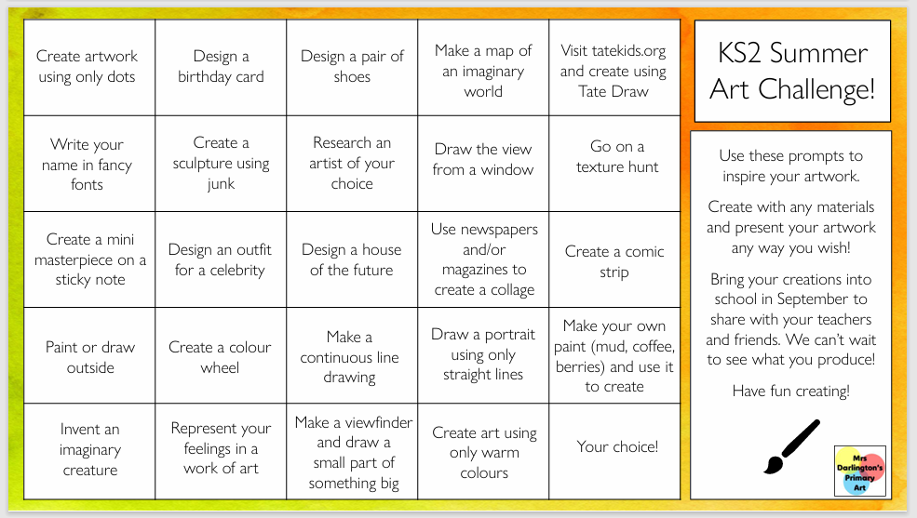

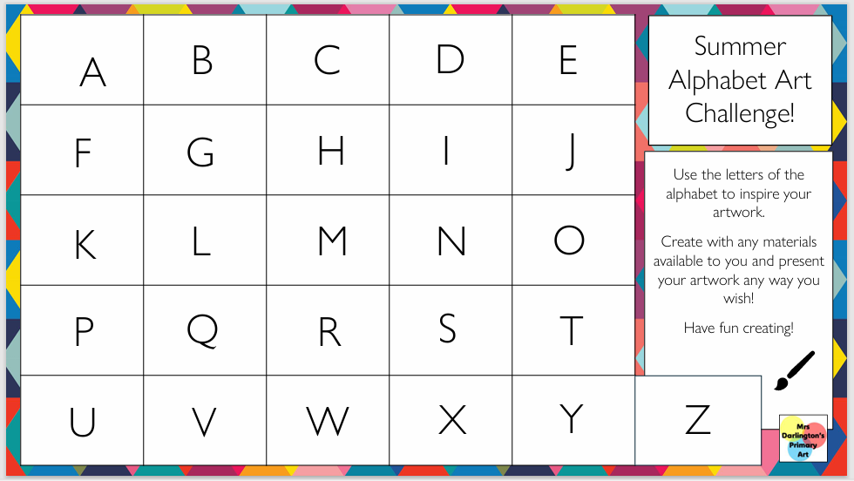
Key Dates
- School closes for the summer holiday at 1:30pm on Friday 19th July.
- School reopens to pupils after the summer holiday on Tuesday 3rd September.

Mrs Sarah Bell
Headteacher

