Friday, 12 July 2024
Dear Parents/Carers,
Punctuality
We had almost 8 hours of lates again this week. Mrs Simmonds and Mrs Iqbal now stand at the gate each morning to monitor the children arriving late to school.

Y1L Fox Class and Y6H Wildcat Class had no lates this week. Well done!

Y6H Wildcats have won the punctuality award this half term and can wear non uniform on Wednesday for their prize!

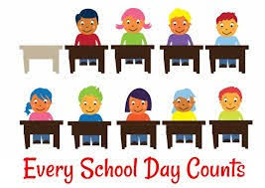
Attendance
Our overall attendance for this week is 92.51%.
Only two classes achieved the 96% target this week.
Y3V Golden Eagle Class achieved 98.57% attendance.
Y2C Woodpecker Class achieved 97.70% attendance.

Y3V Golden Eagle Class has won the attendance award for the half term and can have their non-uniform day on Wednesday for their prize.

Meetings with Teachers
If you wish to meet your child’s teacher to discuss the report that you received this week, please call the school office.

Summer Homework
Suggested ideas were sent home this week for tasks that your children can carry out over the summer. They can bring these in to show their teacher in September. There are some special certificates that children can achieve for joining in with these activities.

Remember that children from Y2 to Y5 have Maths Whizz passwords.
There will be some awards presented in September for children who have used this regularly throughout the summer. 10 minutes a day would make such a difference. Here is a reminder of the forms that were sent home on Wednesday.
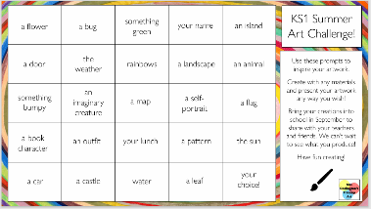
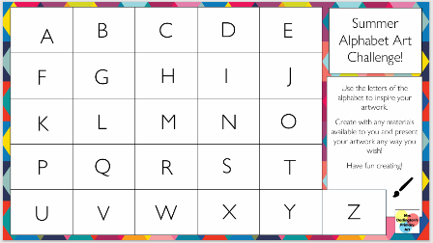
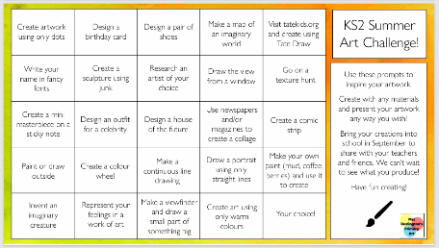

Family Activities in the summer
There are also posters below for activities in the local area that you and your families can access.

Online Safety
All Reedley parents can access the Online Safety Hub FOR FREE. Click on the link below to access the Online Safety Hub for lots of expert advice and guidance to help you manage your child's safety online.
https://reedley-lancs.onlinesafetyhub.uk/

Qustodio
I highly recommend that all parents make use of Qustodio. It is free to use and you can gain more insight into what’s going on in your child’s online world and make sure they are kept safe. Block dangerous content, introduce screen-free schedules, receive alerts for inappropriate content and more.

Follow the link to create your free account: https://www.qustodio.com/en/30-days-school-special/?utm_source=internal&utm_medium=OSHub&utm_campaign=reedley-lancs-uk

All parents/carers can join a webinar on 8th August about how you can support your child’s mental health in relation to the digital age. It is free to join and the details are all below.

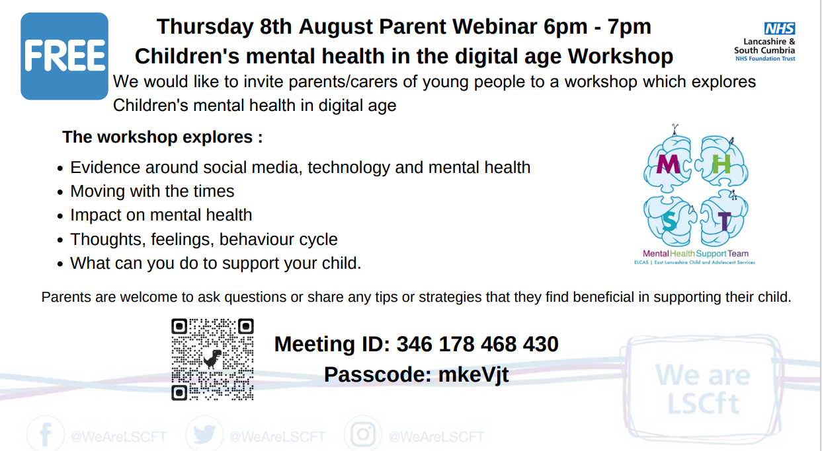

Key Dates
- Y6 families are invited to our Leavers’ Assembly at 9.15am on Friday 19th July
- School closes for the summer holiday at 1:30pm on Friday 19th July.
- School reopens to pupils after the summer holiday on Tuesday 3rd September.
Mrs Sarah Bell
Headteacher

