Monday, 22 July 2024

Dear Parents/Carers,

Thank you for all of your support throughout the school year. It has been a pleasure to see your children flourish! Good luck to the Year 6 children, who leave us all today. We will miss you!

**Swimming**

Please remember that the children will be swimming in September. In the 1st two weeks it will be Y5 and Y6. From 16th September, it will be Y3 and Y4.

**Sue Dean Award**

Muhammad Shafi in Y1 won the Sue Dean Writing Award for this half term.

**Reading for Pleasure Award**

Imaani Amir and Hanna Baig won the Reading For Pleasure award. They each got a £10 book voucher.

**Attendance**

The children with 96+% attendance in the summer term enjoyed a magic show from Scoop on Wednesday. It was amazing to see the bird disappear, and then reappear in a box on the other side of the room! WOW!

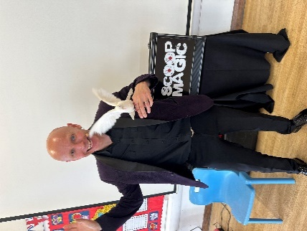

There will be another opportunity to see a show in December for children whose attendance is on green in the Autumn Term.

I hope you all have a safe and happy holiday. Don’t forget to use Maths Whizz to help keep the children’s brains switched on. There is also a challenge running in the local library that children can take part in.

**Key Dates**

* School reopens to pupils after the summer holiday on Tuesday 3rd September.

Mrs Sarah Bell

Headteacher