History
Vocabulary |  | 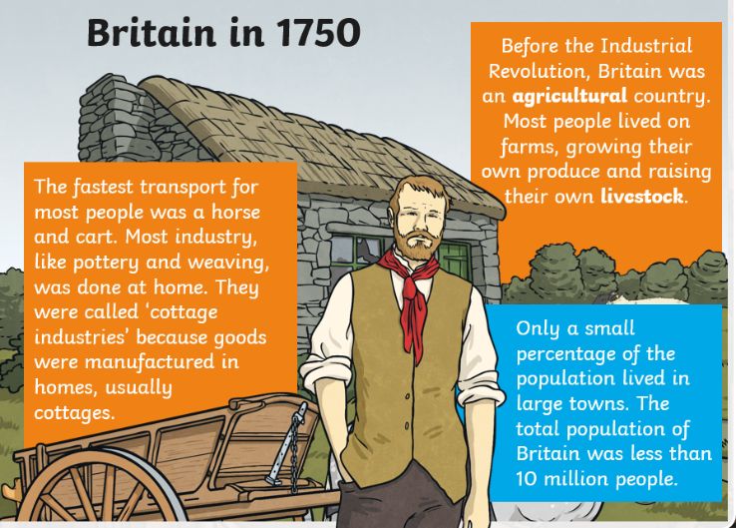  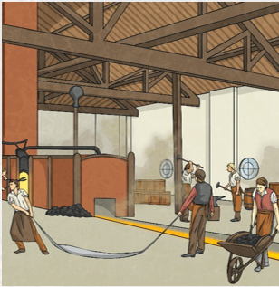  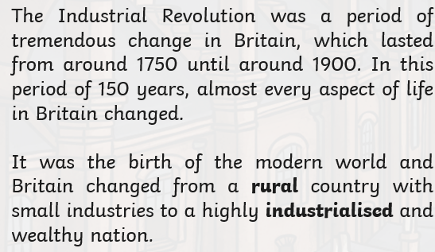
industry | An industry is a group of businesses that make or sell similar products or perform similar services.
revolution | A revolution is a sudden change in government.
locomotive | A self-propelled vehicle that runs on rails and is used for moving railroad cars
textile | The word textile commonly means woven or knitted cloth. Lace, felt, and many other kinds of cloth are considered textiles, too. Even nets, rope, and yarn may be called textiles. People use textiles to make clothing, towels, sheets, table linens, carpets, boat sails, flags, and many other things.
spinning jenny | an early machine for spinning wool or cotton by means of many spindles.
steam engine | Steam engines use the power of steam to operate machines.
cotton mill | A factory for producing cotton fabrics, thread, etc

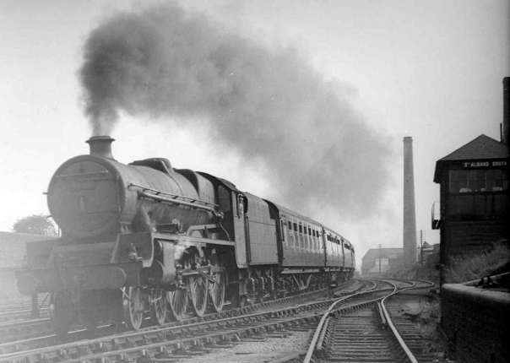  The steam engine helped to power the Industrial Revolution. Before steam power, most factories and mills were powered by water, wind, horse, or man. Water was a good source of power, but factories had to be located near a river. Both water and wind power could be unreliable as sometimes rivers could dry up during a drought or freeze during the winter and wind didn't always blow | Steam locomotives  The basic features that made George and Robert Stephenson’s Rocket of 1829 successful—its multitube boiler and its system of exhausting the steam and creating a draft in its firebox—continued to be used in the steam locomotive to the end of its career. The number of coupled drive wheels soon increased. The Rocket had only a single pair of driving wheels, but four coupled wheels soon became common, and eventually some locomotives were built with as many as 14 coupled drivers.  Steam-locomotive driving wheels were of various sizes, usually larger for the faster passenger engines. The average was about a 1,829–2,032-mm (72–80-inch) diameter for passenger engines and 1,372–1,676 mm (54–66 inches) for freight or mixed-traffic types  