Friday, 13 September 2024

Dear Parents/Carers,

**Swimming**

Year 3 and Year 4 will be swimming for the next two weeks.

|  |  |  |  |  |
| --- | --- | --- | --- | --- |
| Mon 16th Sept  Y4 | Tue 17th Sept  Y3 | Wed 18th Sept  Y4 | Thu 19th Sept  Y3 | Fri 20th Sept  Y4 |
| Mon 23rd Sept  Y3 | Tue 24th Sept  Y4 | Wed 25th Sept  Y3 | Thu 26th Sept  Y4 | Fri 27th Sept  Y3 |

They need:

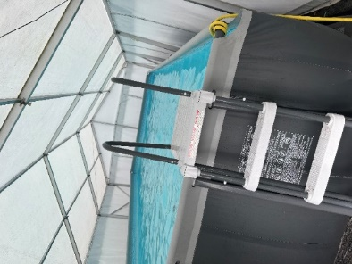GIRLS

* A one-piece swimming costume
* A swimming hat
* Towel
* Dressing gown
* Flip flops/crocs

BOYS

* Swimming trunks or shorts
* Towel
* Dressing gown
* Flip flops/crocs

The children all have individual changing cubicles and will have a shower before and after going in the pool.

**Upcoming Events**

There will be a Phonics workshop for parents of **Reception,** **Year 1 and Year 2** on Thursday 19th September 9:00am- 9:30am.

We will explain what Phonics is and how to explore the reading books with your child. Your child will be able to join you for part of the session.

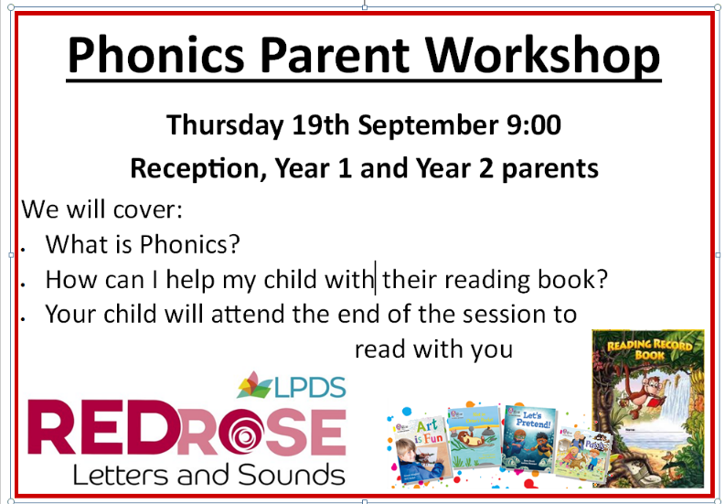

**Rock Kidz**

I am very excited to announce that all children will be taking part in a special event in October from a company called Rock Kidz. They raise the profile of well-being through the power of music. They will transform the school hall into a rock concert for the day, with professional lighting, sound and visual equipment. It will be an extremely active and fun experience. I will send out more details nearer the time, but I am very excited!

Events like this are not cheap to put on so we are aiming to raise money to contribute to the cost by having a **non-uniform day on Friday 20th September.** The event is going to cost around £1000 in total. If each child could bring either £1 or £2, it would really help towards the cost. Our school budget has been cut significantly recently, although costs are still rising at a scary rate. We are only able to provide events such as this if we are able to get enough donations. We would be very grateful for any financial contributions that you can make.



Non Uniform day – Friday 20th September

**Attendance**

The attendance this week was 94.56%. This is a big improvement and is getting us close to our target of 96%. Please keep it up!

I have sent out a number of letters this week informing families if I already have concerns about their child’s attendance. I am hoping the school attendance continues to improves from the poor start that we had.

**Punctuality**

This week we had 3 hours and 50 minutes of late this week.

**Contact Details**

Please ensure that we have up to date contact details for your family. If you, or any of your contacts, change your phone number or email address, you must let us know so we can always get hold of you if your child is unwell.

**Breakfast Club**

Families must book and pay online for each breakfast club session. This starts from 7.30am every day.

You can book online using this link.

Children attending breakfast club need to be dropped off at the **school door** by an adult.

Please do not drive into the staff car park to drop children off.

<https://blooming-buds-childcare.pembee.app/listing/reedley-wraparound>

**Parent Governor**

We are looking to recruit a parent governor. An email was sent out on Wednesday with more details. If any parent is interested in applying for this position, please email me on [recruitment@reedley.lancs.sch.uk](mailto:recruitment@reedley.lancs.sch.uk) no later than 1pm on Monday 23rd September. I will inform you all if we are to hold elections for this post.

**Events that have taken place this week**

**Lego Workshop** - Y1 children took part in a Lego workshop this week. I saw some amazing models of London monuments that the children had made by working well together. Thanks to the families that sent in money to contribute towards the cost for this session.

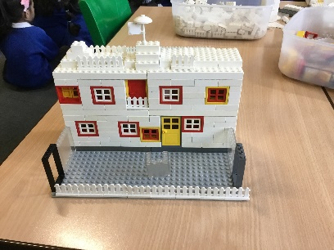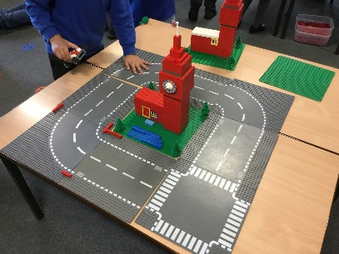

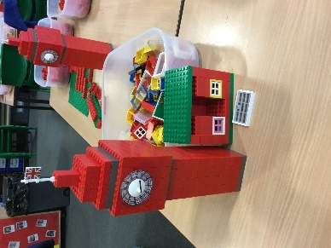

**Purple Maths** - Thank you to the parents who attended the Purple Mash Workshop on Tuesday– it was great to see such a good turnout. Following requests from parents, an information sheet about how to access Purple Mash will be sent home soon and will be put on the parent section of the school website.

**Y6 SATs meeting** – Thanks also to the Y6 parents who attended the meeting on Monday. PowerPoint slides from the meeting are on the class pages of the website.  We will repeat this meeting later in the year for parents who were unable to attend on Monday.

**Asda Rewards**

Please remember that if you sign up for Asda Rewards and select Reedley Primary School, we will get a percentage of your overall spend donated to our school.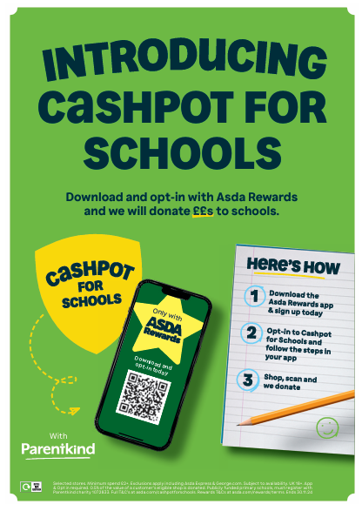

**Key Dates**

* Friday 4th October – families invited into school for MacMillan Coffee morning at designated times.
* School will be closed from Monday 21st October to Friday 25th October for half term.
* A person smiling at the camera

  Description automatically generatedSchool will be closed from Monday 23rd December for the Christmas holiday, and reopen on Tuesday 7th January.

Mrs Sarah Bell

Headteacher