Friday, 20 September 2024

Dear Parents/Carers,

**Swimming**

Year 3 and Year 4 will be swimming for the next week.

Children need to attend swimming lessons. It is part of their compulsory curriculum PE. If you do not have kit, please speak to us as we have some spares.

Jewellery needs to be removed before children get in the pool.

|  |  |  |  |  |
| --- | --- | --- | --- | --- |
| Mon 23rd Sept  Y3 | Tue 24th Sept  Y4 | Wed 25th Sept  Y3 | Thu 26th Sept  Y4 | Fri 27th Sept  Y3 |

They need:

GIRLS

* 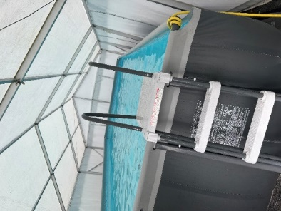A one-piece swimming costume
* A swimming hat
* Towel
* Dressing gown
* Flip flops/crocs

BOYS

* Swimming trunks or shorts
* Towel
* Dressing gown
* Flip flops/crocs

## **What is Beat the Street?**

Beat the Street is a free, fun initiative that will see Pendle transformed into a giant game!

See how far you can walk, cycle, run, scoot and wheel in just 6 weeks. There are great challenges to enjoy and prizes up for grabs.

The game started on Wednesday 18th September and will end on Wednesday 30th October.

Children have been given a card to use for the game.

You will need to register online for your child to play.

Use this link to find more information <https://beatthestreet.me/pendle/>



**Punctuality**

This week we had 4 hours and 45 minutes of late this week. Y4P Red Fox Class were the only class to be on time every day.

**Attendance**

The attendance this week was 95.55%. This is heading in the right direction. Please keep it up!

8 out of 14 classes managed to achieve the 96% target.

Y4P Red Fox Class achieved 99.38%.

I have sent out a number of letters this week if I have been concerned about children’s attendance in the last school year, many of whom took their child out of school last year. I am hoping that we see an improvement this year.

**Leave From School**

You are all aware that by law children have to be in school. We have had a number of children who have already missed days of school over the first three weeks due to extended family holidays.

You can read our Attendance Policy on the school website. If your child will not be attending school for any reason other than illness, the procedure is that you must complete a form which can be collected from the school office. Then you will be contacted by Mrs Simmonds to discuss the proposed absence.

The law has changed since September and the fines and rules for taking children out of school have been amended, especially if you take your child out twice within two years.

**MacMillan Coffee Morning**

On Friday 4th October we are raising money for the MacMillan Cancer Charity.

We would welcome any donations of cakes or biscuits that we can sell. These can be brought into school on Thursday 3rd October or in the morning of Friday 4th October.

Families are welcome to join us in school and your child can join you during the following slots.

**9.00am – 9.20am Reception and Year 1**

**9.20am – 9.40am Year 2 and Year 3**

**9.40am – 10.00am Year 4, Year 5 and Year 6**

If you have children in different year groups, you will have to attend during the different sessions.

Only children who have a parent/carer attending the coffee morning will be able to attend.



If there are biscuits/cakes left at the end of the day, we will sell these after school.

**Breakfast Club**

Families must book and pay online for each breakfast club session. This starts from 7.30am every day.

A number of families are not up to date with their payments. If families do not pay promptly, then the breakfast club may cease operating. Please pay prior to each session.

<https://blooming-buds-childcare.pembee.app/listing/reedley-wraparound>

**Parent Governor**

We are looking to recruit a parent governor. An email was sent out on Wednesday 11th September with more details. If any parent is interested in applying for this position, please email me on [recruitment@reedley.lancs.sch.uk](mailto:recruitment@reedley.lancs.sch.uk) no later than 1pm on Monday 23rd September.

**Events that have taken place this week**

* Thank you to everyone who attended the Phonics Workshop on Thursday.

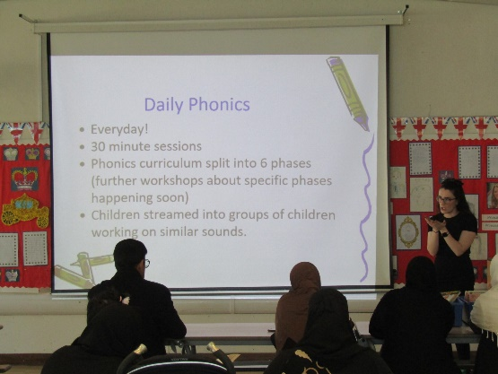

* Some members of our School Council attended a meeting with staff and some of our governors on Tuesday so we could inform them about the role of our governing body and so they could draw parallels between the School Council and Governing Body.



**Parent/Carer/Visitors Code of Conduct**

Wehave a code of conduct which applies to everyone who comes onto the school premises, including high school children, so that we can all work together to support all of our children.

I would like to point out that families should not approach another child to discuss their child’s behaviour.

The code of conduct also applies when speaking to school staff over the phone. If families are offensive or aggressive over the phone, we may discontinue the phone call.

The Code of conduct can be viewed in full on the school website, but I have included some extracts at the bottom of this newsletter.

**Parent/Carer Wellbeing**

I have attached a leaflet below for adults who would like to do art activities to improve their mental health and wellbeing, run by Pendle Council.

**Key Dates**

* Friday 4th October – families invited into school for MacMillan Coffee morning at designated times.
* Thursday 10th October – all children to wear yellow and pay £1 to raise awareness of wellbeing in school.
* Parent/carer meetings with teachers on Tuesday 15th and Wednesday 16th October.
* Art week – week beginning Monday 28th October. Parents/carers will be invited into school for designated slots.
* Y4 trip to Astley Hall. Y4R on Monday 7th October. Y4P on Tuesday 8th October.
* Y5 trip to Clitheroe Castle Y5T on Monday 14th October and Y5H on Thursday 17th October
* School will be closed from Monday 21st October to Friday 25th October for half term.
* School photographs will be on Friday 1st November
* School will be closed from Monday 23rd December for the Christmas holiday, and reopen on Tuesday 7th January.

Mrs Sarah Bell

Headteacher



**Extracts from the Code Of Conduct for Visitors/Parents/Carers**

Visitors, parents and carers are expected to:

* Respect the caring ethos of our school;
* Understand that both teachers and parents need to work together for the benefit of their children;
* Demonstrate that all members of the school community should be treated with respect and therefore set a good example in their own speech and behaviour;
* Seek to clarify a child’s version of events with the school’s view, in order to bring about a peaceful solution to any issue;
* Correct their own child’s behaviour especially in public and in school grounds where it could otherwise lead to conflict, aggressive or unsafe behaviour
* Approach the school to help resolve any issues of concern
* Avoid using staff as threats to admonish children’s behaviour;

In order to support a peaceful and safe school environment, the following behaviours will not be tolerated:

* Disruptive behaviour that interferes or threatens to interfere with the operation of a classroom, an employee’s office, office area or any other area of the school grounds;
* Using loud/or offensive language, swearing, cursing, using profane language or displaying temper.
* Threatening to do actual bodily harm to a member of school staff, volunteer, governor, visitor, fellow parent/carer or pupil regardless of whether or not the behaviour constitutes a criminal offence.
* The use of physical aggression towards another adult or child. This includes physical punishment against your own child on school premises.
* Physically intimidating a member of staff, volunteer, governor or visitor, e.g. standing very close to her/him, the use of aggressive hand gestures, threatening behaviour, shaking or holding a fist towards another person, pushing; hitting, e.g. slapping, punching and kicking, spitting.
* Approaching someone else’s child eg in order to discuss or chastise them because of the actions of this child towards their own child. (Such an approach to a child may be seen to be an assault on that child and may have legal consequences).
* Breaching the school’s security procedures.
* Damaging or destroying school property (or threatening to).
* Abusive or threatening e-mails or text/voicemail/phone messages or other written communication.
* Defamatory, offensive or derogatory comments regarding the school or any of the pupils/parent/staff, at the school on Facebook, Instagram or other social media sites.
* Smoking, vaping and consumption of alcohol or other drugs whilst on school property.
* Dogs being brought on to school premises.

This is not an exhaustive list but seeks to provide illustrations of such behaviour that will not be tolerated.