Class | % Attendance | Position | Points
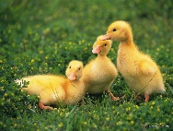  Ducklings Rec H | 96.44
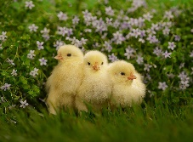  Chicks Rec K | 99.22 | 2 | 4
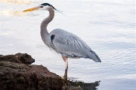  Heron Y1C | 94.83
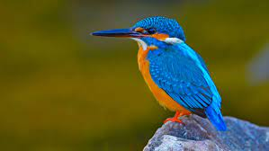  Kingfisher Y1L | 91.03
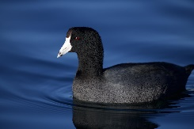  Coot Y2C | 96.56
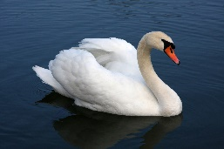  Swan Y2S | 87.41
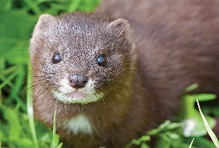  Mink Y3V | 94.67
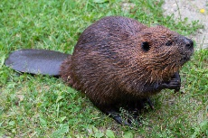  Beavers Y3E | 96.21
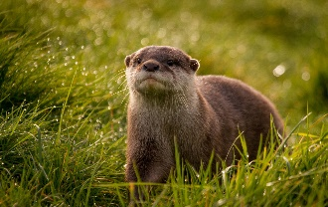  Otter Y4R | 93.75
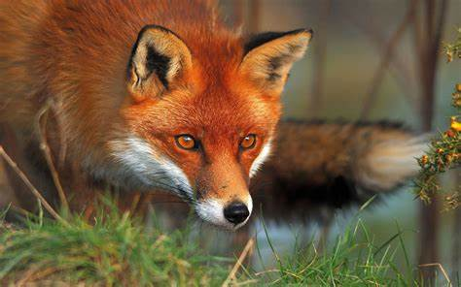  Red Fox Y4P | 99.38 | 1 | 5
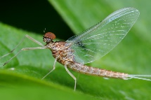  Ephemeroptera Y5H | 97.59 | 4 | 2
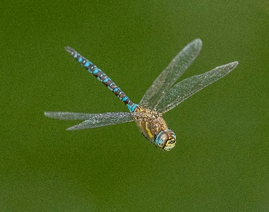  Dragonfly Y5T | 94.52
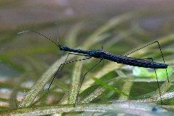  Hydrometra Stagnorum Y6E | 97.33 | 5 | 1
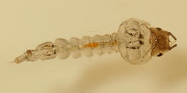  Phantom Midge Larva Y6H | 98.62 | 3 | 3
Whole School | 95.55

