Early/Lower Reedley - Albatross | Early/Lower Reedley - Albatross | Early/Lower Reedley - Albatross
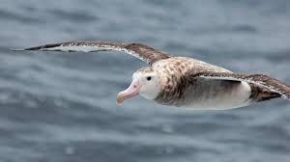  Tell your teacher about an animal character that you like.  Draw a picture of a book that you like to share with someone in your family.  Find a poem or rhyme that you can share with your class.  Draw a picture of an Albatross.  Find a fact about an Albatross.  Choose a book to share with a friend. | 