Middle Reedley - Albatross | Middle Reedley - Albatross | Middle Reedley - Albatross
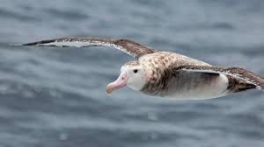  Research and find three animal jokes.  Read a funny book.  Find three interesting facts about an Albatross and share them with a friend.  Read a Roald Dahl book.  Read a story to someone else.  Read a book with a number in the title. | 