Friday, 04 October 2024

Dear Parents/Carers,

|  |
| --- |
| **Beat The Street**  We are currently in 79th place across Pendle for the Beat The Street Scheme. Please remember to scan your card when you walk to school. |

|  |
| --- |
| **Parent/Carer Meetings**  Parent/carer meetings with teachers will take place on Tuesday 15th October and Wednesday 16th October. Appointments are now available to book online.  Parents who have a child with additional needs are invited to meet the class teacher on Friday 11th October instead of attending the parent meetings. Invites for this have been sent home.  If you unable to attend, please call school and rearrange. |



|  |
| --- |
| **MacMillan Coffee Morning**  Thank you for the very generous donations for the coffee morning and for all those families who were able to attend in person. Your support is very much appreciated.  We will let you know how much we have raised once we have finished counting the money.  Thanks to the School Council for helping to sell the cakes. |

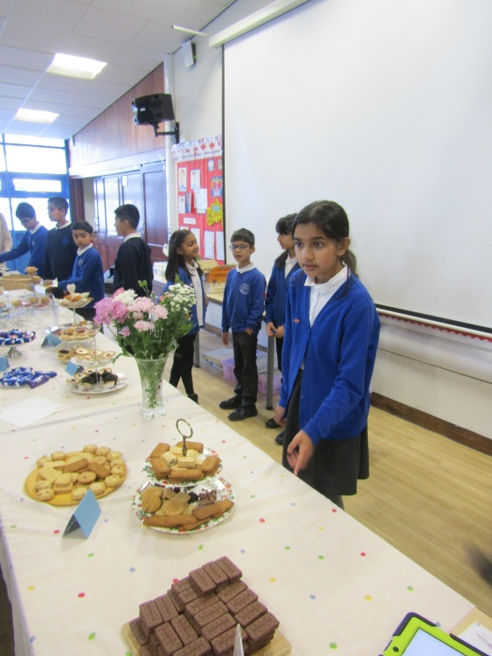

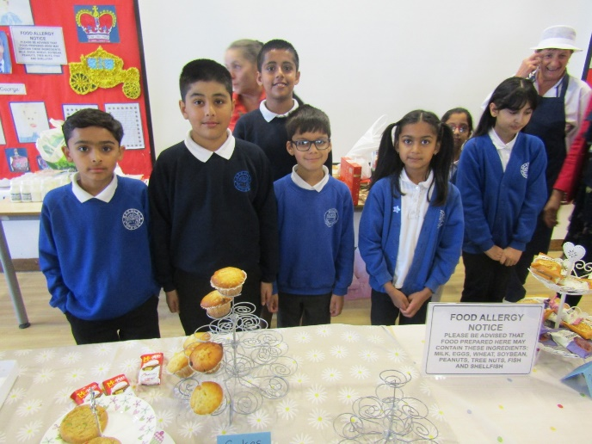

|  |
| --- |
| **Wear Yellow – Thursday 10th October**  We are inviting all children to wear yellow clothes on Thursday to promote wellbeing and to bring £1.  (If they don’t have yellow, they can wear other bright colours.) |

|  |
| --- |
| **Parent Governor Election**  Your child has brought home ballot papers for the parent governor election. You should read the information and vote for one candidate. Your ballot paper goes in the blank envelope and then that envelope goes inside the numbered envelope. Each parent is allowed to vote once.  All ballot papers must be returned to school no later than Wednesday 16th October at 13.00. Late votes will not be counted. |

|  |
| --- |
| **Upcoming Events**  Year 4R - trip to Astley Hall on Monday 7th October  Year 4P - trip to Astley Hall on Tuesday 8th October  Year 4P are going to the swimming pool for lessons in swimming and water safety session, starting on Monday 7th October  Wednesday 9th October – Parent Phonic Workshop of parents of children at Phase 2 Phonics – parents will have received an invite if this applies to you. |

|  |
| --- |
| **Attendance**  Our attendance this week was 94.04%. Well done to the four classes that met our target this week.  Y3E – Beavers 1st Place 99.26%  Y6H – Phantom Midge Larva 98.88%  Y5T Dragonfly 97.08%  Y5H Ephemeroptera 96.64%  **Punctuality**  We had 4 hours and 5 minutes of schooling lost this week due to lateness.  Lessons start promptly at 8.50am and children should be in their classroom for this time. |

Mrs Sarah Bell

Headteacher

|  |
| --- |
| **Key Dates**   * Thursday 10th October – all children to wear yellow and pay £1 to raise awareness of wellbeing. * Parent/carer meetings with teachers on Tuesday 15th October and Wednesday 16th October. * Art week – week beginning Monday 28th October. Parents/carers will be invited into school for designated slots. * Y4 trip to Astley Hall. Y4R on Monday 7th October. Y4P on Tuesday 8th October. * Y5 trip to Clitheroe Castle Y5T on Monday 14th October and Y5H on Thursday 17th October * **School will be closed from Monday 21st October to Friday 25th October for half term.** * Monday 28th October - Rock Kidz On Tour are visiting school. More information to be sent out nearer the time. On this day children can dress as a rock or pop star. Please ensure that all outfits are appropriate and suitable for school. * School photographs will be on Friday 1st November * **School will be closed from Monday 23rd December for the Christmas holiday, and reopen on Tuesday 7th January.** |

