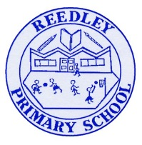Year 5 Homework

**Date homework set:** 7.11.24

**To be returned to school by: 12.11.24**

|  |
| --- |
| Image result for clipart talking**Talking Topic**   * To discuss the following topic:   Image result for small square“How is Diwali celebrated?”  Tick when you have completed this task. |
| **Maths** Complete and learn the following;   * Complete 3 steps on Maths Whizz. I want you to complete this activity, it will help improve your Maths. * Times tables Rock Stars. Remember the more practice you do the better your maths is. **Complete this task.**     Image result for small square  **Image result for clipart maths black and white**Tick when you have completed these tasks. |
| **Reading:** Image result for person readingRead the next chapter from your new reading for pleasure book   * **Complete your next book mark.** * **Image result for small squareRead to an adult and ask them to sign your Reading Diary.**   Tick when you have completed this task. |
| Image result for spelling clipart black and white**Spelling: Learn this week’s spellings and include them in a sentence.**  Because  Symbol  Stomach  Image result for small squareDesperate  Embarrass  Tick when you have completed this task. |
| **Spag. Com**  *Complete the SPAG.com activity- cohesion.* |
| Image result for writing clipart**Writing -** Write a paragraph explaining why light is important when celebrating Diwali. Key skill, include the relative clause- which.  Tick when you have completed this task.  Image result for small square |

Extra spag activities

Complete each sentence with either is or are.

That perfume  expensive.Those shoes  Ralph's.The men  looking at a car.

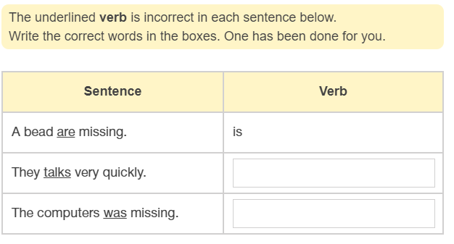

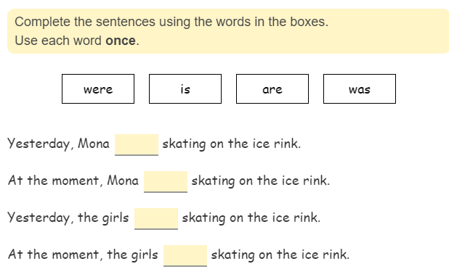

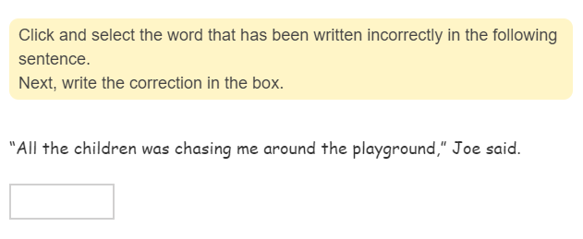

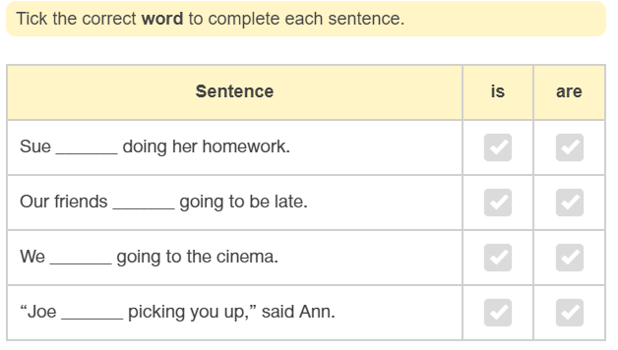

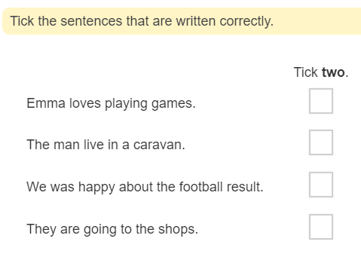

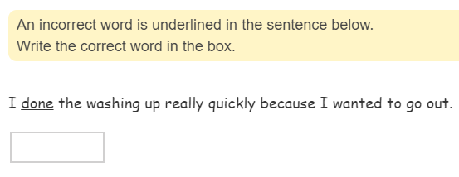

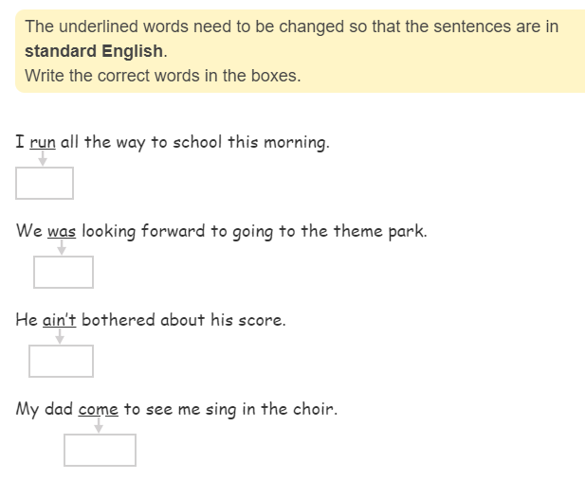

My Maths

