Pupil premium strategy statement 2024 - 25

This statement details our school’s use of pupil premium (and recovery premium for the 2021 to 2022 academic year) funding to help improve the attainment of our disadvantaged pupils.

It outlines our pupil premium strategy, how we intend to spend the funding in this academic year and the effect that last year’s spending of pupil premium had within our school.

School overview
Detail | Data
School name | Reedley
Number of pupils in school | 396
Proportion (%) of pupil premium eligible pupils | 23%
Date this statement was published | 16 9 24
Date on which it will be reviewed | 1.7.25
Statement authorised by | Sarah Bell - Headteacher
Pupil premium lead | Sarah Bell
Governor lead | Jilly Walton

Funding overview
Detail | Amount
Pupil Premium Funding allocation this academic year (a) | £140600
Recovery Premium Funding allocation this academic year (b) | 0
Pupil premium funding (Catch Up) carried forward from previous years (enter £0 if not applicable) (c )
Total budget for this academic year for Recovery and Pupil Premium Funding a+b+c | £140600
School-led tutoring for this academic year (d)
Total budget for this academic year inc tutoring  a+b+c+d | £140600

Part A: Pupil premium strategy plan

Statement of intent
What we aim to achieve by allocating the Pupil Premium Money
To narrow the attainment gap between disadvantaged and non-disadvantaged pupils nationally and also within internal school data.

Our definition of disadvantaged pupils includes those pupils who are eligible for the Pupil Premium grant, those currently entitled to FSM, service children and those who are in the care of the local authority.

Key Principles of how we will achieve our aim:
- Senior members of staff meet with the classteachers and TAs termly to identify and analyse the barriers and needs of the children eligible for the grant.
- Strategies are devised, with clear next steps, to support these children.
- Staff use achievement data to monitor the attainment and progress of all children, and to analyse the impact of the strategies used.
- Children who need additional support to fill gaps. This takes the form of pre-teach or over-learning sessions responding to need, or can be a structured programme.
- Teachers receive high-quality professional development, which ensures that teaching and learning opportunities meet the needs of all the pupils
- School has invested in mathematical materials to support learning in maths and a structured mathematical programme for all children throughout school.
- Appropriate support is made for pupils who belong to vulnerable groups, this includes ensuring that the needs of socially disadvantaged pupils are assessed and addressed
- Additional staff will be deployed across school to support classes and groups of children in catching up and filling gaps in learning.
- A range of software is provided to support learning needs within school, including for those children with additional needs and to support all children in consolidating skills out of the school day.
- Staff to receive additional training to support the emotional and social needs of the children in school alongside a new Mental Health Policy.
- Headteacher to undertake Mental Health Champion Training.
- Providing opportunities for our families to have a greater role in the life of the school

We recognise that not all pupils who are socially disadvantaged are registered or qualify for free school meals. We reserve the right to allocate the Pupil Premium funding to support any pupil or groups of pupils the school has legitimately identified as being socially disadvantaged.

Pupil Premium Funding will be allocated following a needs analysis which will identify priority classes, groups or individuals.

Challenges

This details the key challenges to achievement that we have identified among our disadvantaged pupils.
The children who are eligible for the pupil premium grants often face many and varied barriers to educational achievement, which can include:

Challenge number | Detail of challenge
1 | - Little or no spoken English
2 | - Weak levels of language and communication
3 | - Attendance/punctuality issues, including families taking extended leave for lengthy periods of time
4 | - Lack of emotional resilience
5 | - Less support at home
6 | - Complex or unsettled family arrangements
7 | - Limited progress made during the COVID pandemic

Intended outcomes
This explains the outcomes we are aiming for by the end of our current strategy plan, and how we will measure whether they have been achieved.

Intended outcome | Success criteria
Progress in the aspects of Reading, Writing and Maths | For the vast majority of the children from Y1 – Y6 to make expected progress across the school year.
For the disadvantaged children to attain well in Reading, Writing and Maths | To reduce the gap in attainment of the disadvantaged children from those who are not disadvantaged.
For children across Rec and KS1 to make good progress in phonics | The vast majority of children from R – Y2 to meet the national expectations in phonics.
To provide effective behaviour and nurturing support for children | For selected children to have appropriate support to support a range of behavioural, social and emotional needs, reducing their barriers to learning.
To improve the attendance of the disadvantaged children | Take steps to ensure that the attendance of the disadvantaged pupils is 95%+

Activity in this academic year
This details how we intend to spend our pupil premium (and recovery premium funding) this academic year to address the challenges listed above.

Teaching (for example, CPD, recruitment and retention)
Budgeted cost: £50000

 | Activity and Evidence that supports this approach | Challenge number(s) addressed
To ensure first quality teach for all pupils in school | Day to day teaching meets the needs of each learner by ensuring that all children have access to First Quality Teaching (FQT).  This approach is supported by the Sutton Trust, which evidences that first quality teaching has a direct impact on positive pupil outcomes.  Staff will receive training and updates in FQT including giving positive feedback as formative assessment.  Evidence for this approach:  https://educationendowmentfoundation.org.uk/guidance-for-teachers/assessment-feedback?utm_source=/guidance-for-teachers/assessment-feedback&utm_medium=search&utm_campaign=site_searchh&search_term  Use of instructional coaching to support individual members of staff, with ensuring that planning, teaching and learning are of the highest standard. Training to be provided by Nick Broome of Athena Education.  Teaching staff attend up to date courses in Maths, English and Assessment, as necessary, to ensure that they are fully aware of all new developments in teaching to allow them to deliver the Quality First Teaching.  SLT spend time working with staff to monitor the use of feedback and to liaise with staff. Staff training will be provided as necessary.  Teachers spend time working with children, to give them 1-1 feedback on their work and on occasions will be released from class by support staff to meet with children for this purpose. 1-1 pupil conferencing is used to support children with the development of their writing. | 1, 2, 5, 6, 7
To ensure first quality teach for all pupils in school | Range of strategies are in place to support the oracy of children. All staff receive training, and support to discuss the strategies.  Subject leaders and SLT will carry out monitoring in this area including carrying out pupil interviews. | 2
 | All teaching staff receive high quality professional development opportunities challenging appraisal targets linked to attainment and progress of children eligible for Pupil Premium.  Interim reviews will take place and lesson observations will include a focus on children eligible for Pupil Premium.  Support Staff - regular meetings to discuss performance including appraisal with HT/DHT and phase leader, to discuss their performance including reviewing their intervention programmes and their outcomes and impact upon learning.  Senior leaders analyse termly any gaps in attainment and/or progress of children eligible for the Pupil Premium funding, which dictates where the greatest need is, including carrying out regular monitoring of the intervention programmes.  Pupil Progress Meetings are held with teachers at least termly to discuss outcomes for all groups including children eligible for Pupil Premium. This will involve setting challenging targets for identified children to make accelerated progress.  Programme of monitoring across school including book scrutinies, pupil interviews, lesson observations and learning walks. This will include a focus on children eligible for Pupil Premium to monitor their progress against challenging targets. Subject leaders monitor their own subjects and report impact, including that of groups, to governors and SLT. Target Tracker resource will be used to track the attainment of the children eligible for pupil premium in order to provide support for them. | 1, 2, 7
Speech and Language support | All children in Reception, Y1, Y3 to have their speech and language competency assessed.  School buy in a Speech and Language therapist (Bridge) to support range of children across school with detailed support sessions and plans.  Support programmes to be delivered to those children who require additional support.  Evidence supporting this approach:  The Nuffield Early Language Intervention case study showed that supporting in this area has a positive impact on the language skills of children in a trial. | 2
To promote a love of reading | All staff to promote reading with the children  Strategies will include:  - FBA book club  - Additional 1-1 readers  - Reading buddies  - Reading in Magic festival  - Author visits  - Reading Buddies  - Training volunteer readers  - To encourage children to take part in Reedley’s Reading For Please scheme  - High quality texts to be shared with children through English lessons and through reading aloud to the class  High quality phonics sessions are taught at least daily to those pupils who require it in groups smaller than whole classes.  Synthetic phonics approaches have a strong evidence base which indicates a positive impact on the accuracy of word reading, particularly for disadvantaged pupils.  Evidence for this approach:  https://educationendowmentfoundation.org.uk/evidence-summaries/teaching-learning-toolkit/phonics/ | 2, 5, 6, 7
High quality CPD | To continue to use Red Rose Maths programme along with a range of apparatus, to provide training for teachers in the delivery of the maths programme and time for SLT to monitor and give feedback and support to teachers.  To support selected teachers to take part in quality CPD for English, through local authority training packages. | 7

Targeted academic support (for example, tutoring, one-to-one support structured interventions)
Budgeted cost: £50 000

 | Activity and Evidence that supports this approach | Challenge number(s) addressed
To provide support to address children’s gaps in learning | Teaching Assistants and teachers across school will deliver a wide range of structured interventions using Primary Sentence Toolkit  Intervention will include specific programmes such as catch up phonics Bounce Back and Fast Track phonics, Reciprocal Reading, Communication in Print, Colourful Semantics, WELLCOMM (speech and language).  Teaching Assistants will also respond to need on a daily basis, by delivering sessions to children who need some pre teach intervention or over learning following a lesson based on formative assessment.  Classteachers to coordinate the delivery of intervention sessions such as precision teaching, pre-teach and overlearning sessions, to support children who need additional support.  SLT monitor the quality of the provision across school and monitor the writing outcomes for pupils eligible for Pupil Premium funding.  Techniques to include Talk for Writing, Reciprocal Reading and modelling high quality writing. | 5, 7
Purchase of resources to facilitate the support provided for pupils | ICT intervention programmes eg Nessy, Purple Mash, Maths Whizz, TT Rockstars, Spag.com, | 1, 2, 7

Wider strategies (for example, related to attendance, behaviour, wellbeing)
Budgeted cost: £40000
 | Activity and Evidence that supports this approach | Challenge number(s) addressed
Support emotional needs of children | HT and PSM to make regular contact with parents/carers regarding attendance and punctuality issues.  Small group support to be provided for children who need support with attendance, behaviour, punctuality or social and emotional support. | 4, 5, 6
Promote good attendance and punctuality | Pupil Support Manager to engage with children to promote positive attendance, to support children with low attendance or persistence absences. PSM to support children across the school who need behaviour support to minimise disruptions within classes. Pupil Support Manager to work with families who require additional support to reduce the barriers to learning. CPOMS, Studybugs and Insight resources areused to monitor the attendance, attainment, behaviour and welfare of our children. | 3
Give children a positive start and end to the day | Provision of regular after-school clubs covering variety of skills and provision of materials to support curriculum learning at home inc subscription of computer programmes enabling pupils to complete homework set by school staff including Spag.com, Phonics Play, MyMaths, Purple Mash. | 3, 5, 6, 7
Create broader experiences for all children | Visitors to be brought into school to enhance learning opportunities for children who are eligible for Pupil Premium grant to further challenge their academic development.  Range of trips will be subsidised by the school to ensure that children have board and cultured experiences.  RE SLA will allow for multi-faith visits/trips to take place. | 1, 2, 5
Support for families | Additional support will be allocated to families of children at the Headteacher’s discretion. This includes supporting with items of uniform, subsidising school trips and other items which will enable children to overcome barriers to learning or attending school.  Headteacher will also access range of funding opportunities to support families as necessary eg purchase of white goods, beds etc. | 5, 6
Provide specialist support for children and training for staff | To provide a range of bought-in services such as the Educational Psychologist, specialist teachers to provide support for children and to train staff members to deliver specialist programmes of support | 2, 5, 7
Support children with transition | To provide support for children moving on to high school and to those who will move to a different class/phase. Staff will liaise regarding the academic and pastoral needs of these children. They will support children in visiting their new class. | 4
Engaging parents in the life of the school | We recognise the value of families being involved in their child’s education and will seek to build on the existing positive relationships with parents/carers.  We will support with specific training programmes such as phonics workshops and Maths Whizz parental sessions.  We will invite families to come to a range of assemblies where children can share key messages eg online safety, Eid  Families will be invited to join in activities related to their child's education, such as Art Week.  Evidence for this approach  https://educationendowmentfoundation.org.uk/tools/guidance-reports/working-with-parents-to-support-childrens-learning/ | 1 2 5 6

Part B: Review of outcomes in the previous academic year

Pupil premium strategy outcomes
This details the impact that our pupil premium activity had on pupils in the 2021 - 2022 academic year.

Attendance
Attendance for the year was 92.4% whole school
91.8% for the children eligible for PP grant

Non-disadvantaged children
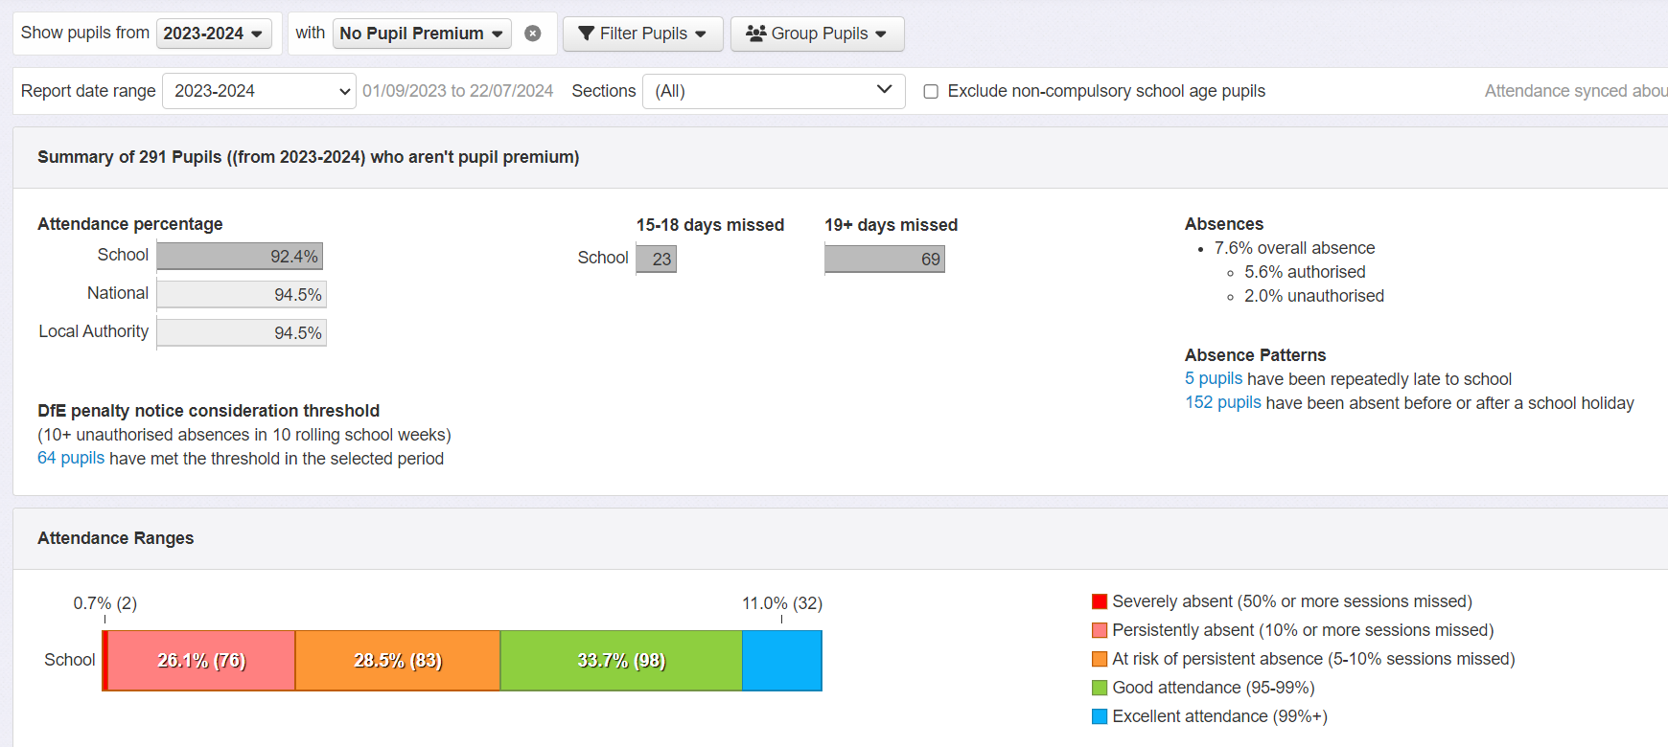

Disadvantaged children
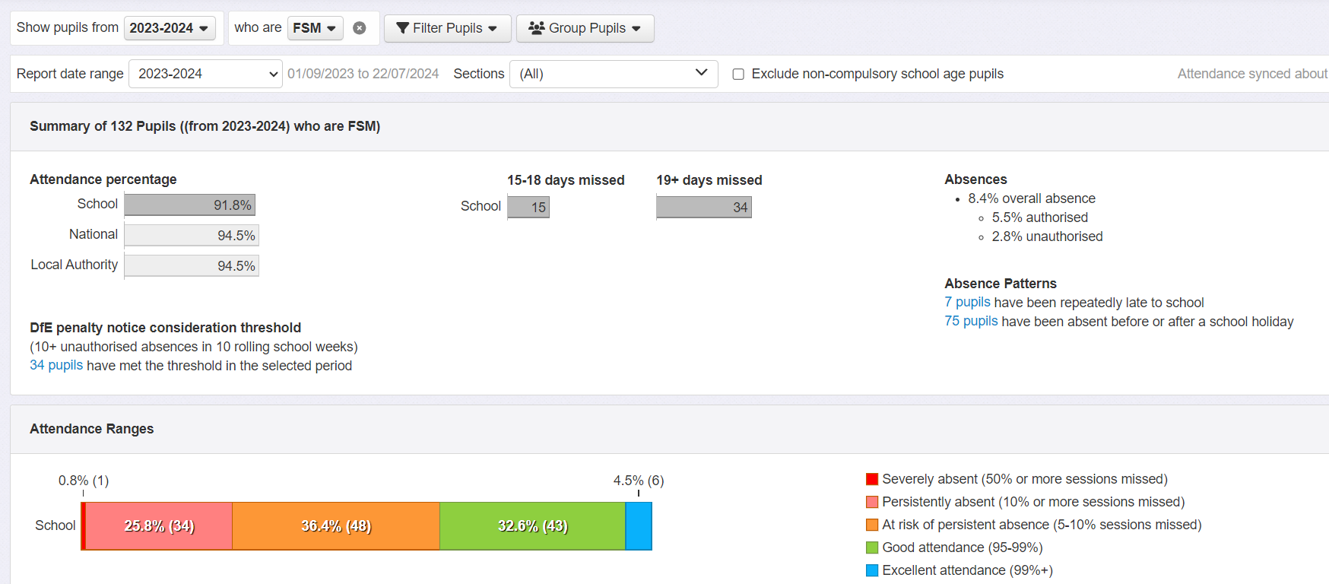

Academic support
In many aspects of school, disadvantaged children are working in line or better than the non-disadvantaged children.
Attainment for disadvantaged children across school Y1 – Y6
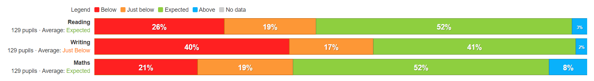
Attainment for non-disadvantaged children across school
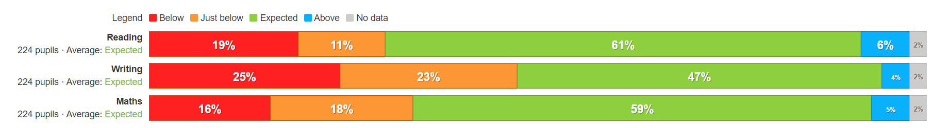
EYFS data
Disadvantaged children
Non - disadvantaged children

Y1 Phonics
Disadvantaged children achieving Phonics by Y1
Non -disadvantaged children achieving Phonics by Y1
Y2 Phonics
Disadvantaged children achieving Phonics by Y2
Non - disadvantaged children achieving Phonics by Y2
End of KS2 SATs data
Reading: disadvantaged children
Reading: non-disadvantaged children
Writing: disadvantaged children
Writing: non -disadvantaged children
Maths: disadvantaged children
Maths: non -disadvantaged children

Speech and Language
Speech and Language is the predominant area of need in school.
Internal school data shows that the levels of speech and language that children arrived with in reception class were well below the national expectations. Throughout 2023/24 the children made very good progress in this area, resulting in some of the children catching up to the national expectations, and others making considerable progress towards this.
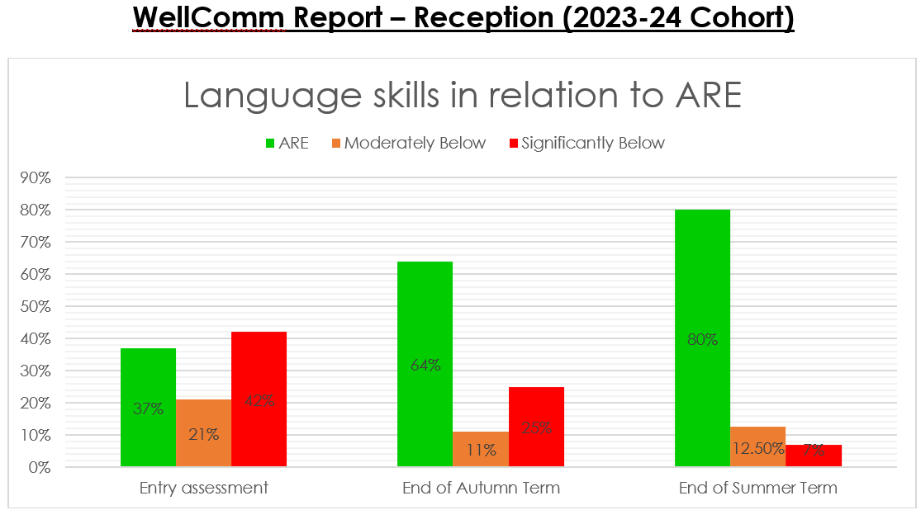
Social and Emotional Support
-Range of strategies to support social and emotional wellbeing of pupils from Pupil Support Manager and other members of staff.
-A number of children also accessed support from the school counsellor, bringing about significant changes in their mental wellbeing.

Externally provided programmes
Please include the names of any non-DfE programmes that you purchased in the previous academic year. This will help the Department for Education identify which ones are popular in England
Programme | Provider
Times Table Rockstars
My Maths
Spag.com
Purple Mash
Nessy
Maths Whizz

