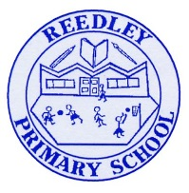Year 5 Homework

**Date homework set:** **27.11.24**

**To be returned to school by: 3.11.24**

|  |
| --- |
| Image result for clipart talking**Talking Topic -** To discuss the following topic:  Image result for small square“What is the Jabberwocky?”  Tick when you have completed this task. |
| **Maths Complete and learn the following;**     * Complete three steps in ***Maths Whizz*** * Times tables Rock Stars. * Learn your 9 times tables.Image result for small square   **Image result for clipart maths black and white**Tick when you have completed these tasks. |
| **Reading**  Image result for person readingRead the next chapter from your new reading for pleasure book.   * **Image result for small square**Continue with your next book mark. Remember when you have completed your book mark, you will receive a certificate and your name will be read out in Friday’s assembly. * **Read** to an adult and ask them to sign your **Reading Diary.**   Tick when you have completed this task. |
| Image result for spelling clipart black and white**Spelling -** Practice the spellings below.  suggest  system  average  symbol  vehicle  Image result for small square  Tick when you have completed this task. |
| **Spag.** Complete the activity. |
| **Writing**  Write a poem.  Key Skill: Rhyming a,a,b,b,a.  Tick when you have completed this task.Image result for small squareImage result for writing clipart |
|  |
|  |
|  |
|  |
|  |
|  |
|  |
|  |
|  |
|  |
|  |
|  |
|  |
|  |