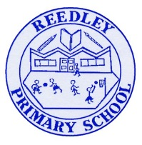Year 5 Homework

**Date homework set:** **4.12.24**

**To be returned to school by: 10.12.24**

|  |
| --- |
| Image result for clipart talking**Talking Topic -** To discuss the following topic:  *Image result for small square“What does advent mean?”*  Tick when you have completed this task. |
| **Maths Complete and learn the following;**  Find the area of the two shapes below and **complete the next three steps** on **Maths Whizz.**     * Times tables Rock Stars. * Learn your 8 times tables.Image result for small square   **Image result for clipart maths black and white**Tick when you have completed these tasks. |
| **Reading** Image result for person readingRead the next chapter from your new reading for pleasure book.   * **Image result for small square**Continue with your next book mark. Remember when you have completed your book mark, you will receive a certificate and your name will be read out in Friday’s assembly. * **Read** to an adult and ask them to sign your **Reading Diary.**   Tick when you have completed this task. |
| Image result for spelling clipart black and white**Spelling -** Practice the spellings below, using the pyramid method.  beautiful  difference  vegetable  Image result for small squareinterrupt  Tick when you have completed this task |
| **Spag.** Complete the activity.  On Spag.com camplete the suffixs and prefixes. |
| **Writing. Key skill- relative pronoun – which.**  Write a list of instruction to make soup.  Image result for small squareTick when you have completed this task.Image result for writing clipart |