**Q1.**

**VOLCANOES**

Eruption of Vesuvius

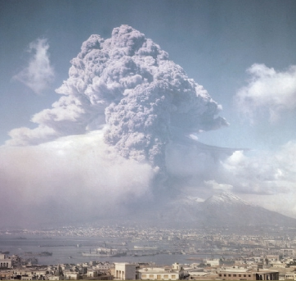

              Not far under the surface of the Earth, it is hot. The further down you go inside the Earth, the hotter it becomes. Deep, deep down below our feet, it is so hot that even the rock melts and is nine times hotter than boiling water. In places where the Earth’s surface is weak, this liquid rock can bubble up and burst through. These weak spots are the world’s volcanoes.

              Volcanoes fall into three groups, depending on how active they are. Volcanoes which are erupting are called **active**. Volcanoes which show no signs of eruption are known as **dormant** or sleeping and, if they remain dormant for tens of thousands of years, they may be described as **extinct**.

              When we hear of a volcano erupting, we think of a tall cone-shaped mountain sending out clouds of ash and liquid rock called **lava.** In fact, volcanoes can be of different types: some are broad and flat, many are under the sea, some pour out streams of red-hot lava, some create an explosion that can be heard thousands of miles away, while others are quieter and ‘gentler’.

              There are some volcanoes that can cause massive destruction although they produce little or no lava at all. The most well-known of this type is Mount Vesuvius in Italy. This is what happened in the famous eruption of Vesuvius, which destroyed the town of Pompeii over 1900 years ago.

|  |  |  |
| --- | --- | --- |
| The Eruption of Vesuvius, AD 79 | | |
| At midday on 24th August, Vesuvius erupted, sending a cloud of ash, pumice and other rock 20 kilometres into the air. This covered Pompeii in 2 metres of rubble but it did not kill anyone. | After midnight, the cloud collapsed. It sent a surge of ash and hot gas mainly down the western slope of the mountain, at a speed of 160 kilometres per hour. | Early the next morning another surge of blistering ash and rock swept down the slopes. This time it covered the town of Pompeii and burnt and suffocated everyone there. |

**Q2.**

1.      Circle the correct option to fit the passage.

(a)     Under the Earth’s surface, it gets



1 mark

(b)     Most people think that volcanoes are

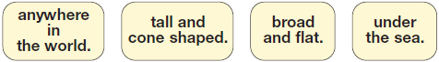

1 mark

(c)     An active volcano is one that is



1 mark

2.      Fill in the facts about the eruption of Vesuvius in the table below.

One box has been filled in as an example.

|  |  |
| --- | --- |
| Date and time eruption started | *Midday, 24th August, AD 79* |
| Height of volcanic cloud |  |
| Depth of rubble over Pompeii |  |
| Contents of volcanic cloud | •  • |

3 marks

3.      Using the information from the text, tick one box in each row to show whether each statement is **true** or **false**.

The first one has been done for you.

|  |  |  |
| --- | --- | --- |
|  | ***True*** | ***False*** |
| There are two types of volcano. |  | ***✔*** |
| Lava consists of liquid rock. |  |  |
| Some volcanoes are under the sea. |  |  |
| All volcanoes produce loud explosions. |  |  |

1 mark

4.      ... *this liquid rock can ...* ***burst*** *through*.

What does the word *burst* tell us about the movement of the lava?

___________________________________________________________________

___________________________________________________________________

___________________________________________________________________

2 marks

5.      Look at the section headed *The Eruption of Vesuvius*.

**Find** and **copy one** word which tells you that the ash was dangerously hot.

___________________________________________________________________

1 mark

Mark schemes

**Q2.**

1.      Award **1 mark** for each correct choice.

(a)     Under the Earth’s surface, it gets



(b)     Most people think that volcanoes are

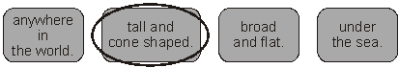

(c)     An active volcano is one that is



**Up to 3 marks**

2.       Award **1 mark** for each correctly completed cell, to a maximum of **3** marks.

|  |  |
| --- | --- |
| Date and time eruption started | *Midday, 24th August, AD 79* |
| Height of volcanic cloud | 20 kilometres / km (not metres)  (unit of measurement must be included) |
| Depth of rubble over Pompeii | 2 metres / m (not kilometres)  (unit of measurement must be included) |
| Contents of volcanic cloud | Any **two** of:  •      ash  •      pumice  •      rock  •      (hot) gas.  **Also accept** rubble when included with  (hot) gas or ash.  **Do not accept** rubble when included  with pumice or rock. |

**Up to 3 marks**

3.       Award **1 mark** for all three answers completed correctly.

|  |  |
| --- | --- |
| There are two types of volcano. | ***F*** |
| Lava consists of liquid rock. | **T** |
| Some volcanoes are under the sea. | **T** |
| All volcanoes produce loud explosions. | **F** |

**1 mark**

4.       Award **2 marks** for answers referring to explosiveness / building up of pressure, eg:

•      *it’s like it blows the top of the mountain off and comes squirting out from inside the Earth*

•      *it tells us that the lava is going to break through in something like spring-like action*

•      *it moves with force and speed and finally overcomes the restraint of the rock itself.*

          Award **1 mark** for answers referring to speed, suddenness or power, eg:

•      *it comes out fast*

•      *it tells us that the lava is strong and powerful*

•      *fast and can demolish anything in its way.*

**Do not accept** answers that simply present an analogy, or refer to eruption, without explaining the effect of the word *burst*, eg:

•      *it bursts like a balloon*

•      *it erupts.*

**up to 2 marks**

5.       Award **1 mark** for either of the following words:

•      *blistering*

•      *burnt.*

**Also accept** a short phrase from the text containing one of these words. Ignore minor errors in copying.

**1 mark**