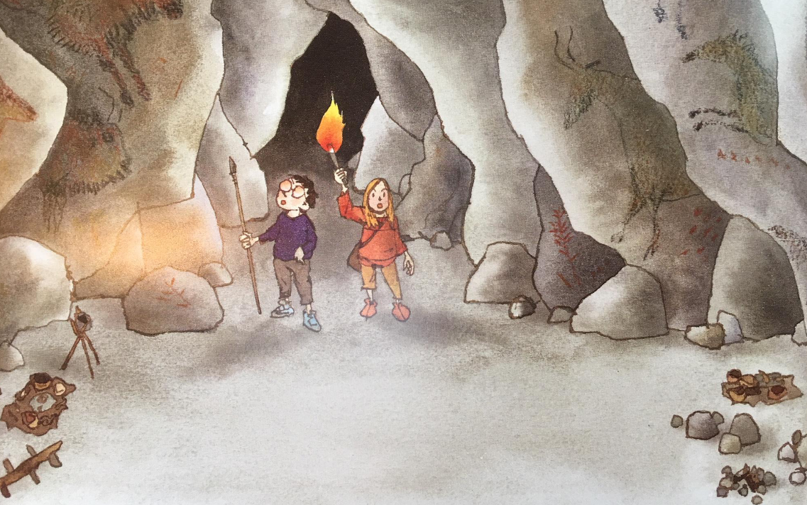

* Predict who the people in the picture are
* Predict where the characters are
* Predict what they are doing there

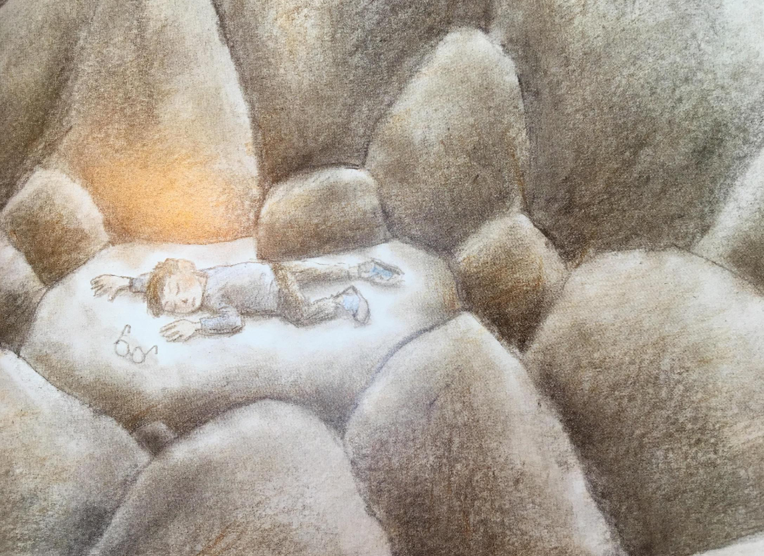

* Predict how the boy got down there
* Predict who is going to help him