Wednesday 8th January 2025

KL – To name and identify the 7 continents

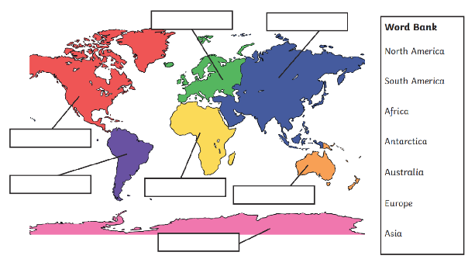

Wednesday 8th January 2025

KL – To name and identify the 5 oceans

**Word bank**

Pacific Ocean

Atlantic Ocean

Southern Ocean

Arctic Ocean

Indian Ocean

