Thursday 9th January 2025

KL – To make simple inferences

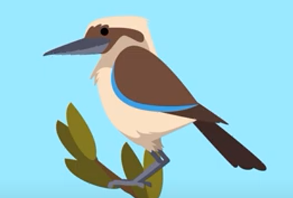

How is kookaburra feeling?

__________________________________________

__________________________________________

__________________________________________

What is Kookaburra thinking?

__________________________________________

__________________________________________

__________________________________________

What might kookaburra say?

_________________________________________

_________________________________________

_________________________________________

Thursday 9th January 2025

KL – To make simple inferences

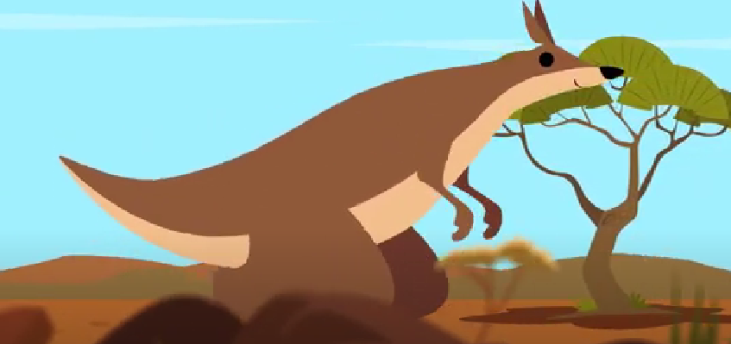

How is kangaroo feeling?

__________________________________________

__________________________________________

__________________________________________

What is kangaroo thinking?

__________________________________________

__________________________________________

__________________________________________

What might kangaroo say?

_________________________________________

_________________________________________

_________________________________________