**Autumn 1 – Marvellous Me**

During the first weeks of school the children enjoyed getting to know the staff, each other and the environment.

There were sessions focusing on our name: recognising the letters, ordering the letters, coping the letters and then independently writing our names.

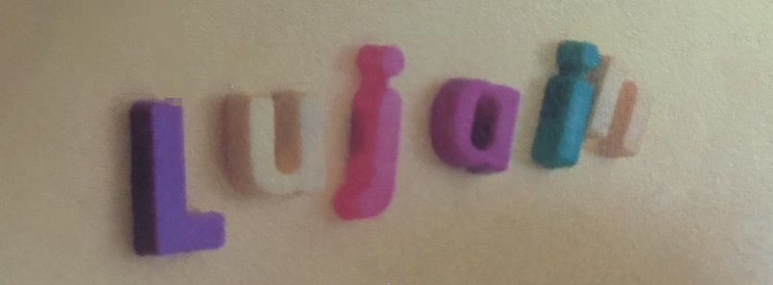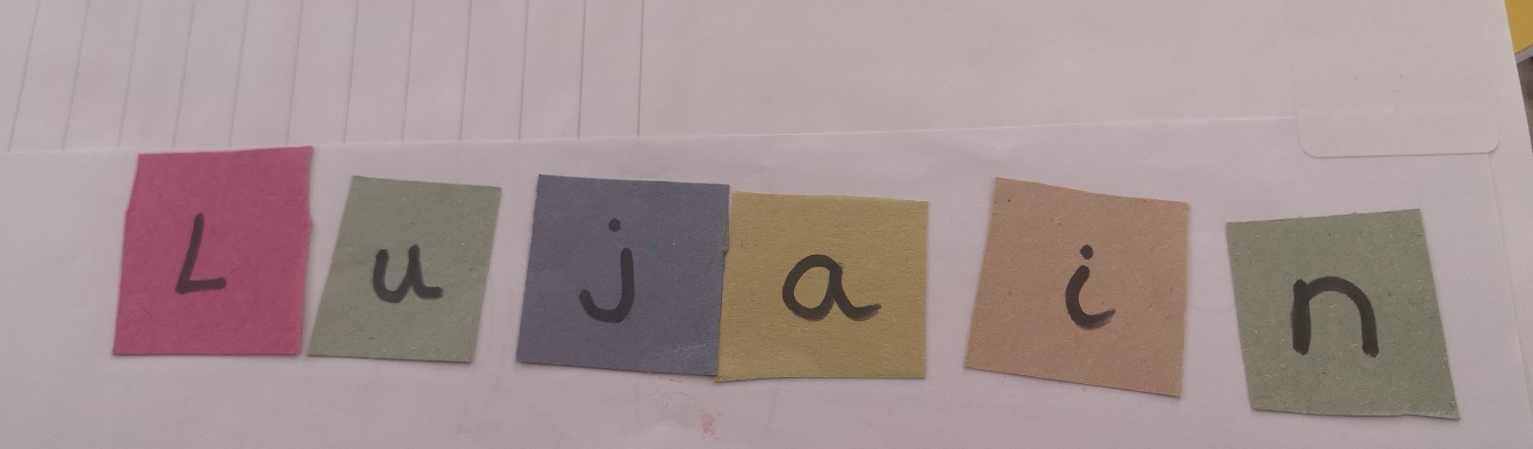

We spoke about who was in our families and used language from our knowledge organisers such as ‘daughter’ and ‘son’.

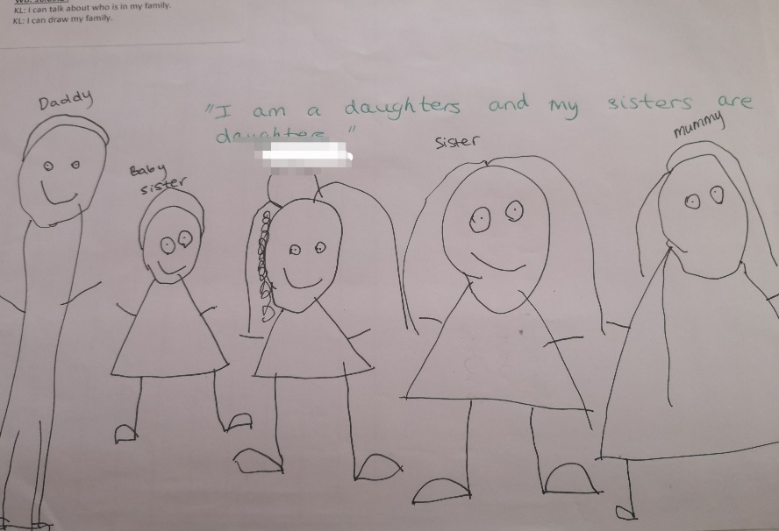

We used mirrors to look at our faces and create our own wonderful self-portraits.

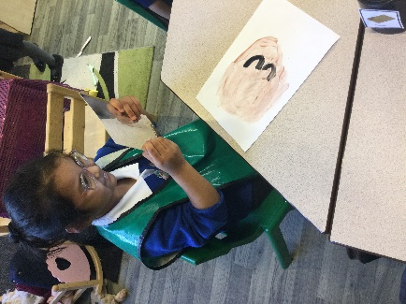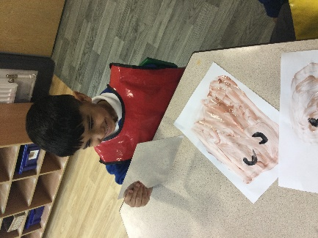

We read the book ‘We’re All Wonders’: this helped us to talk about ourselves, what we liked to do and how we were special and unique.

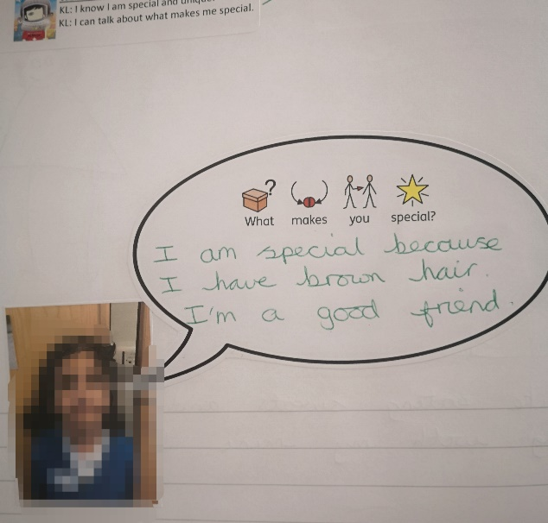 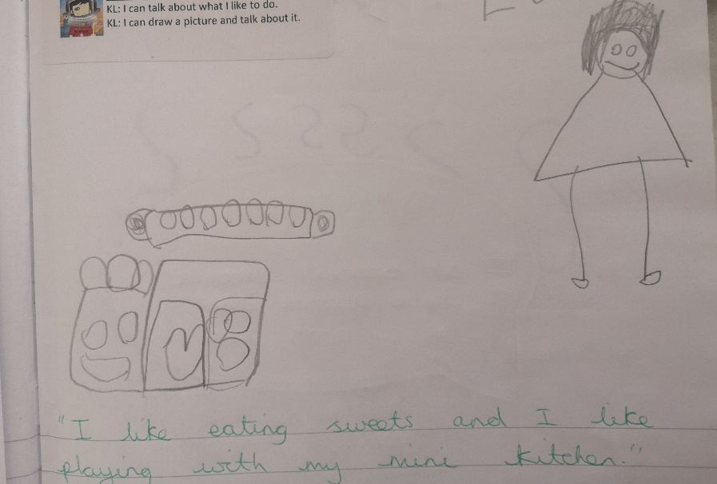

We love to learn and explore outdoors.

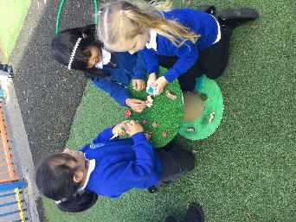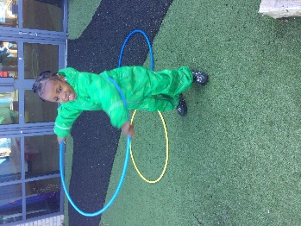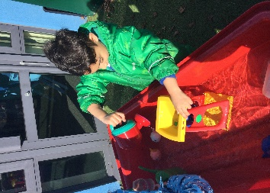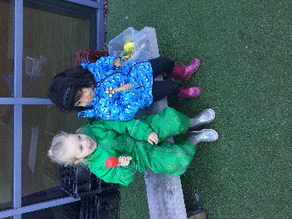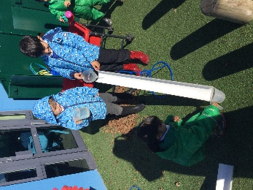

Next we read the book ‘Martha Maps it Out’ – this showed us what maps were, then we focused on making maps of our homes, our route to school and learnt about different types of houses.

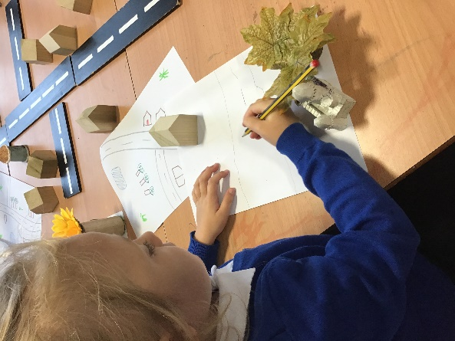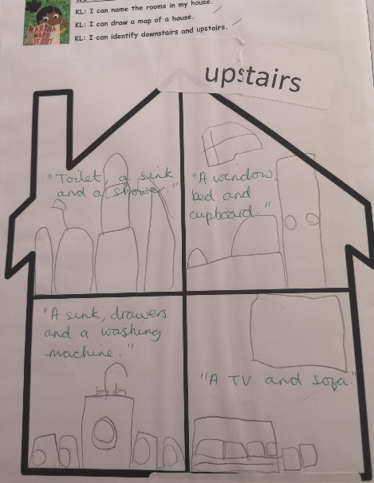 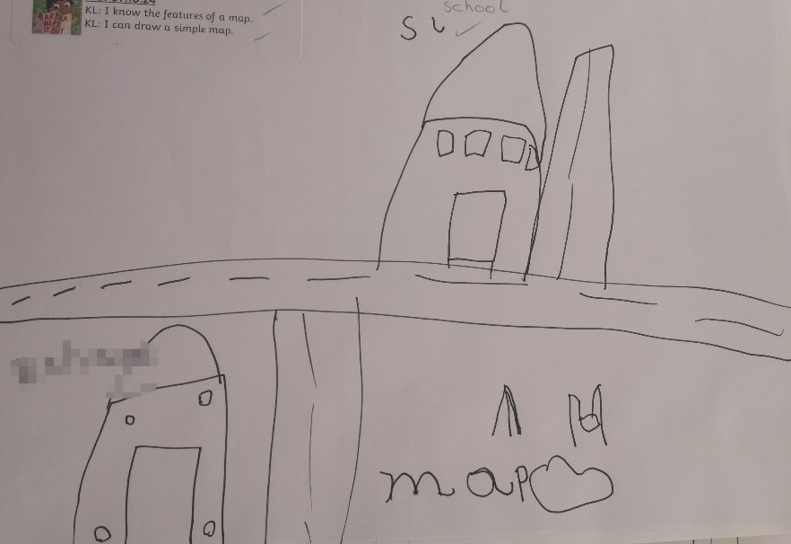 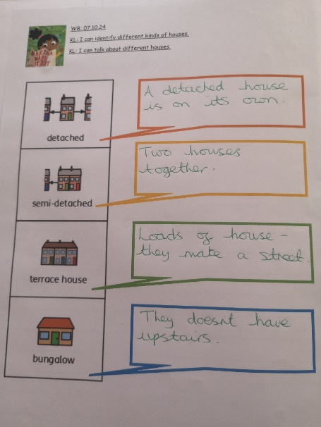

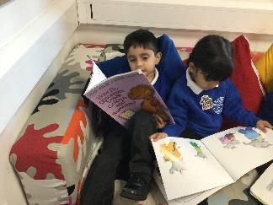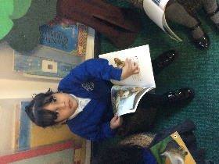We enjoy our visits to our school library. We have lots of lovely books to read.

During this term there was the celebration of Diwali. We learnt about this special celebration, read the story ‘Binny’s Diwali’, made Diva lamps and drew chalk Rangoli patterns. In Literacy we wrote the colours we could see in this Rangoli pattern.

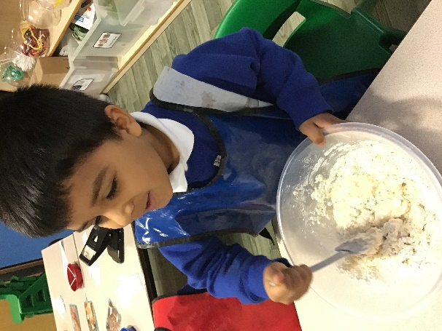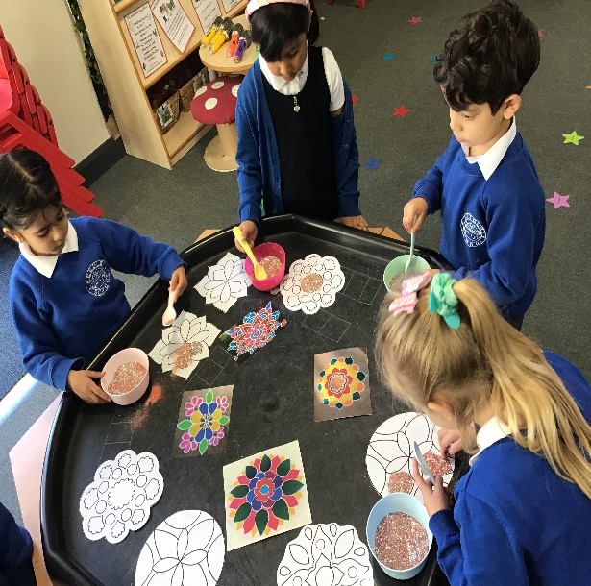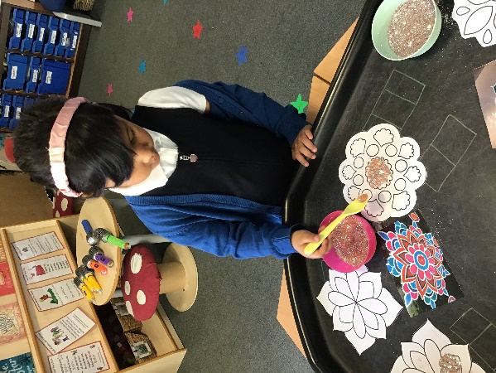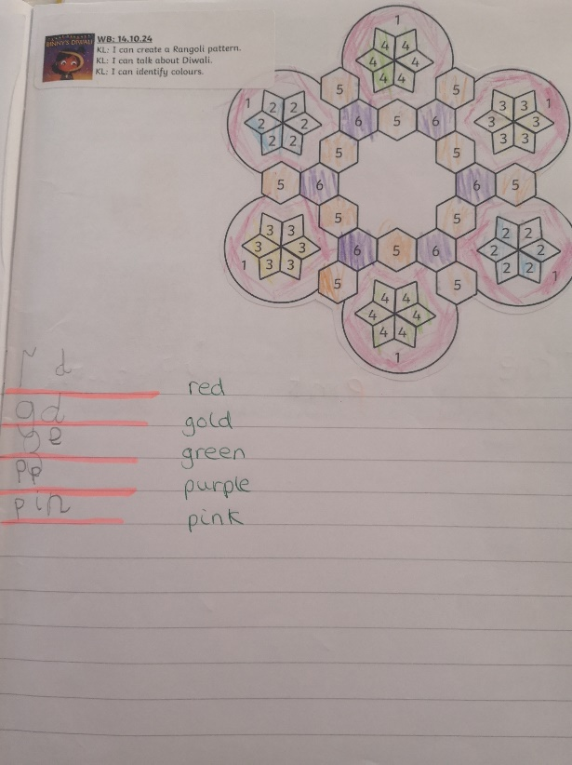

The next exciting celebration to happen was ‘Bonfire Night’: we learnt about how it started and how it is celebrated today.

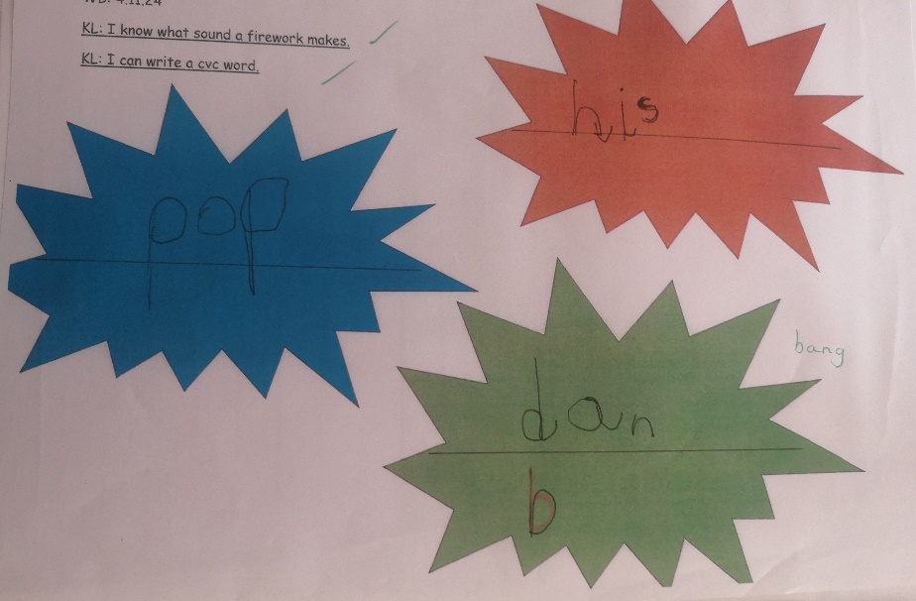 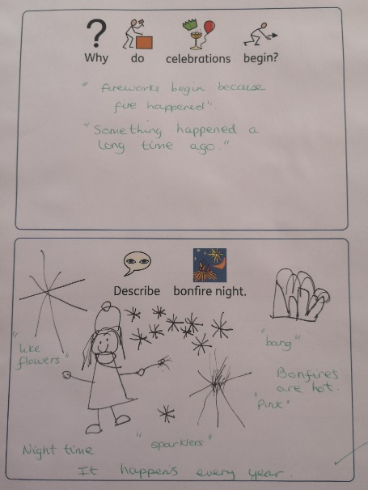

We enjoy thinking about what we would like to build in the construction area.

