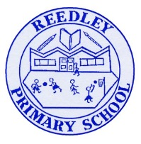
Year 5 Homework
Date homework set: 3.10.24
To be returned to school by: 10.10.24


Talking Topic To discuss the following topic:
“What is trust?” Tick when you have completed this task.
Maths : Complete the task below.
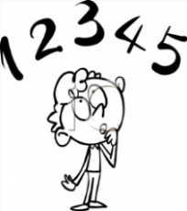
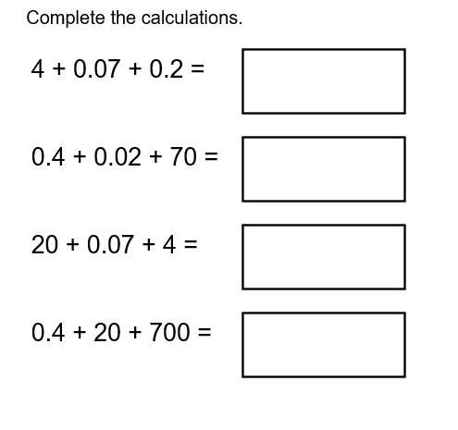
When you have completed the above Maths complete 3 steps on Maths Whizz. https://whizz.com/
Tick when you have completed these tasks.
Reading

- Read the next chapter from your new reading for pleasure book. Ask someone to listen to you read.
- Complete your next bookmark.
Tick when you have completed this task.
Spelling : Learn this week’s spellings. Include them in a sentence.
Excited ,
Drenched,
Confused,
Devastated,
Aggressive
Tick when you have completed this task.
Spag. Complete the activity on SPAG. Com. Verbs in perfect form. https://www.spag.com
Writing. Imagine you are walking around the school field, write two paragraphs describing the school field. What do you see and hear. Key Skill: Expanded noun phrases.
Reminder:
If you would like extra homework there are more activities on:
Times Tables Rock Stars – Times Tables Rock Stars (ttrockstars.com)

