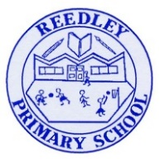Year 5 Homework

**Date homework set:** 09.12.24

**To be returned to school by: 17.12.24**

|  |
| --- |
| Image result for clipart talking**Talking Topic**   * To discuss the following topic: * Image result for small square“Who celebrates Christmas?”   Tick when you have completed this task. |
| **Maths** Complete and learn the following;     * Times tables Rock Stars. * Complete **three steps on Maths Whizz**.   Image result for small square**Image result for clipart maths black and white**Tick when you have completed these tasks. |
| **Reading**   * Image result for person readingRead the next chapter from your new reading for pleasure book. * **Continue with your next book mark.** * ***Image result for small squareRead to an adult and ask them to sign your Reading Diary. Your reading diary will be checked.***   Tick when you have completed this task. |
| Image result for spelling clipart black and white**Spelling: Learn this week’s spellings and include each one in a sentence.**  Defensive  Refine  Microscope  Image result for small squareTelescope.  Tick when you have completed this task. |
| **Spag.com**  Image result for writing clipartComplete the activity below on Spag.com.  Complete **relative clauses.** |
| **Writing:** *I want you to write a letter to the Jabberwocky explaining why he is not a nice person.*Image result for small square  Tick when you have completed this task. |