Vocabulary Dozen |  | Place knowledge | Where I live?
Atlas | Book of maps. | Brierfield today  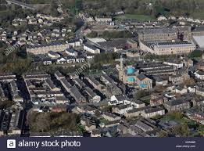  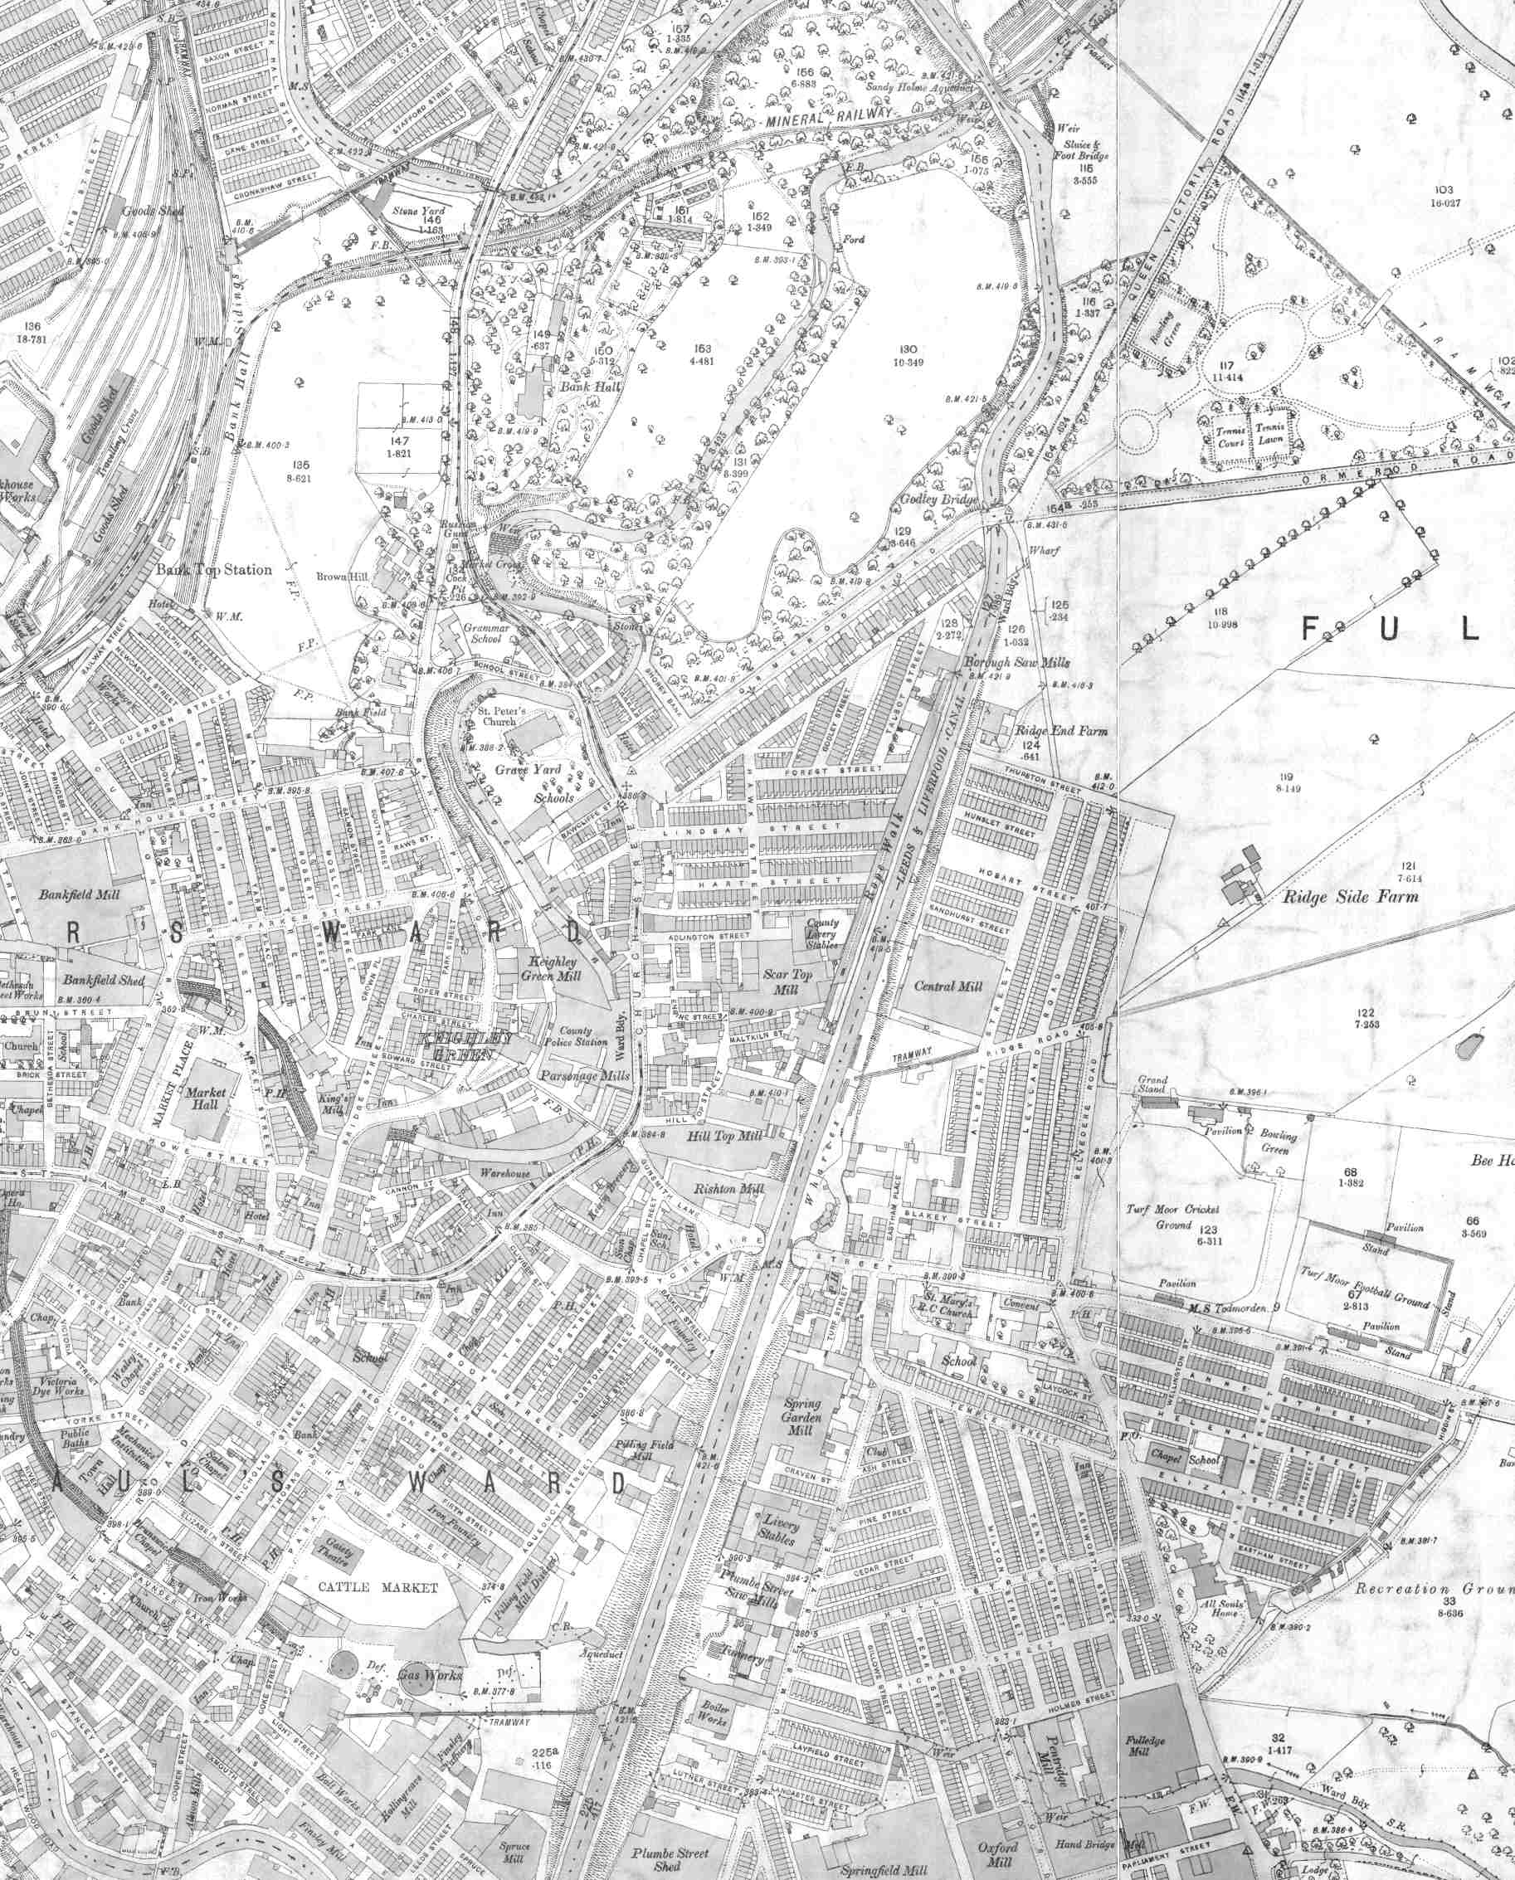 | •The place where I live in is called Brierfield (Burnley, England)  •Burnley is in England, which is a country.  • Burnley is in Lancashire, which is a county (there are 48 counties in the UK).  •England, which is in the United Kingdom, is in the continent of Europe.  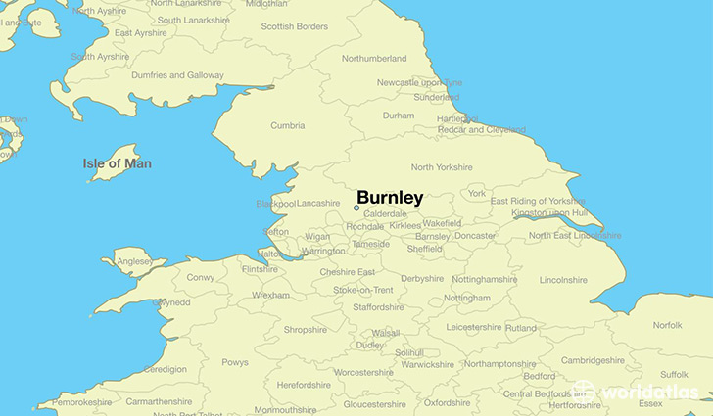
Latitude | Lines that go from the north pole to the south pole and help us identify where a place is on a globe.
Longitude | Lines that go horizontally around the globe to help us identify where a place is.
Equator | The line of longitude around the centre of the earth (at its widest part). It goes from East to West.
Northern hemisphere | The north part of the globe (top part down to the Equator.
Human Geography | Features of land that have been impacted by human activity.
Physical Geography | Natural features of land.
Climate | Climate describes what weather is like in a place over a long period of time.
Continent | A very large area of land that consists of many countries. Europe is a continent.

