Year 5 Homework

Date homework set: 01.12.22
To be returned to school by: 06.12.22
Talking Topic (10 minutes)
- To discuss the following topic:
“Who was our special visited this week? What did they talk about?”
Tick when you have completed this task.
Maths (10 minutes)
Complete the following:

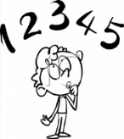
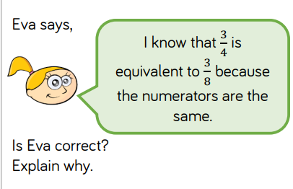

Tick when you have completed these tasks.
Writing (10 minutes)
Write a diary entry as the son in the Jabberwocky. Think about how we feels after winning the battle.

Spellings:
Learn these spellings and include them in your writing:
- Curiosity
- Deteremined
- Sacrifice
- Physical
- Soldier
Tick when you have completed this task.

