Upper Reedley - Albatross | Upper Reedley - Albatross | Upper Reedley - Albatross
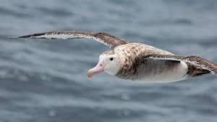  Visit a library with an adult or go on Bugclub.  Explain which writer you like best: Dahl or Morpurgo. Give reasons.  Read a Roald Dahl book.  Read a comic. Share your favourite part with a friend.  Find three interesting facts about an Albatross and share them with a friend.  Read an information book. What information can you discover about an albatross? | 