Upper Reedley - Elephant | Upper Reedley - Elephant | Upper Reedley -Elephant
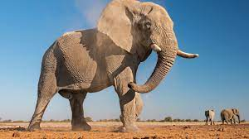  Describe what a character may be thinking and explain why.  Write a speech bubble for a character.  Read a book of your choice. Explain your choice to your teacher.  Research and make a flip book.  Read a book by an author you haven’t read.  Read a book with ‘The’ in the title. | 