Upper Reedley - Firefly | Upper Reedley - Firefly | Upper Reedley - Firefly
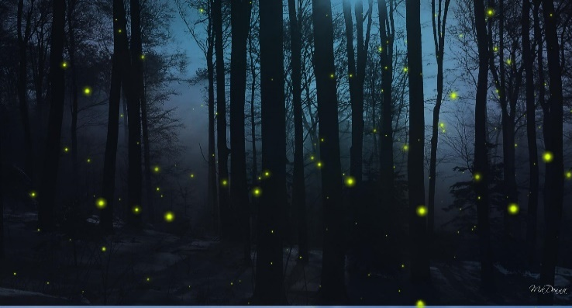  Visit the website of your favourite author and share a fact you have learnt.  Write a thought bubble for an evil character.  Research Fireflies.  Draw a labelled diagram to share information you have discovered.  Draw a cartoon version of an event that you enjoyed.  Summarise a story in a sentence. | 